THE LEGEND OF THE GOLDEN TREE
In the district of St. Fruttuoso there is a road between tall buildings: the road of the Golden Tree.
This name comes from a legend narrating that in the district of St. Fruttuoso there were many woods, gardens and orchards. It was a district inhabited by farmers, that lived in small cottages in the green.
The greatest part of those cultivated grounds belonged to a gentleman of the place, known as a lazy person. He loved to live in luxury, he visited only the richest people in the city and played dice.
But gambling had never brought anything good: the gentleman quickly lost everything of his possessions getting into debt with a lot of people. He was convinced to be able to win the game and to return as rich as before. The last time he tossed dice he bet one of his trees as a reward. He won the game and had all his money back.
He was happy, but he wasn’t the same any longer: he had been turned into a humbler man.
In fact, he understood that that tree represented the courage to take his responsibility.
That tree became his mascot and took him out of gambling.
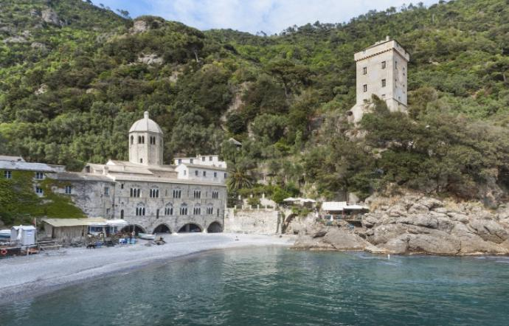
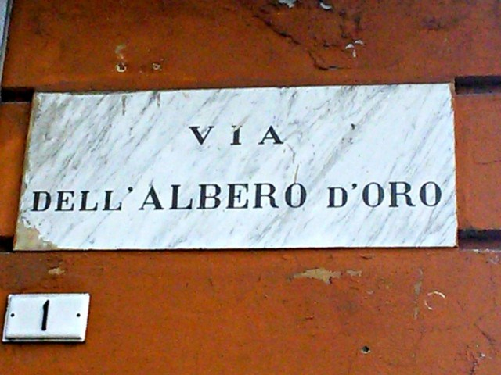
In the 80s an old tree was cut down in the street of the Golden Tree and according to the legend it was the tree of the gentleman.
Many people believed in this legend so a new tree was planted.
The tree is symbol of good luck.

