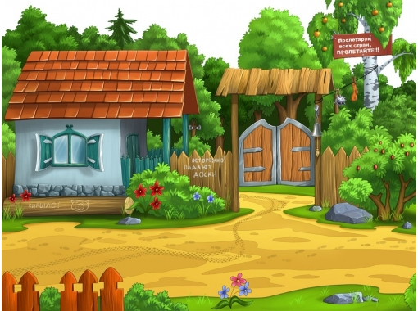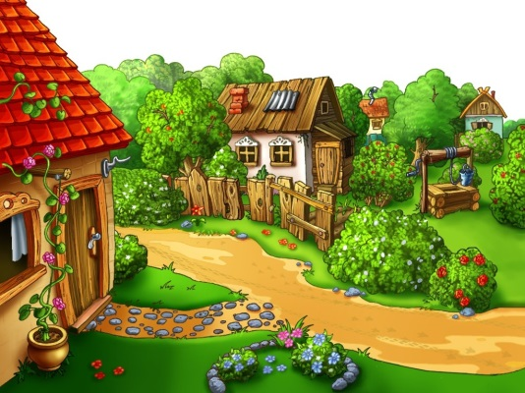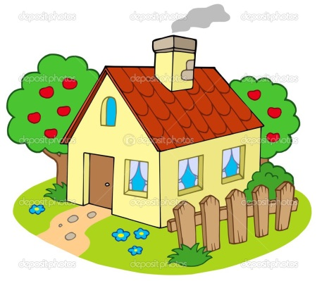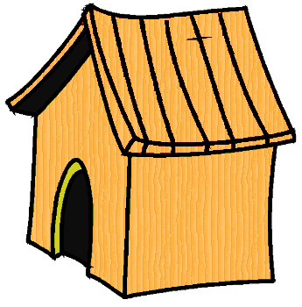

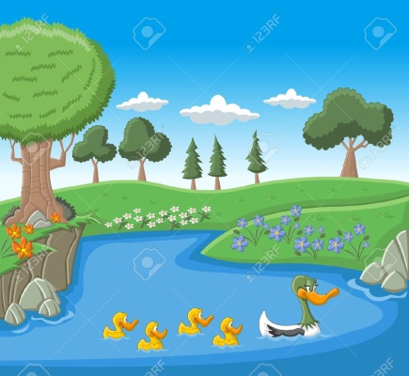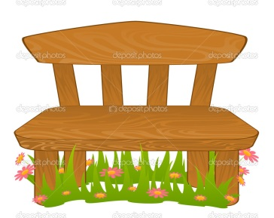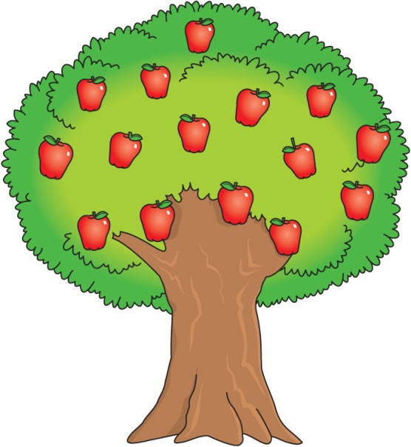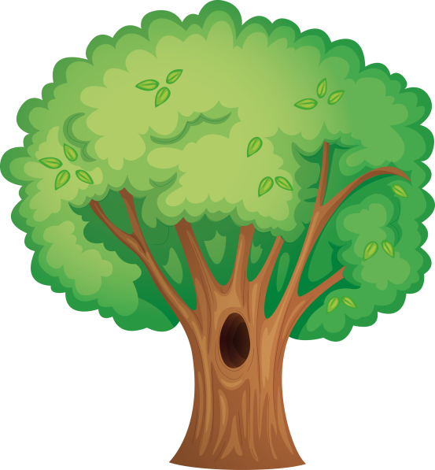

The mouse route “ A bell for a cat”
Children can cut out a mouse, read the text, fill in the gaps with prepositions, where the mouse goes to the cat.
A young mouse is going to go ….. the trunk, … the gate, …. the path, …. the fence, …. the kennel, …. the pond, … the bench, ….the tree,… the hollow of the tree, … the cat and when a cat sleeps a mouse puts on a little bell on a cat.
Past, onto, under, past, around, into, along, under, through, along.

A young mouse is going to go along the trunk, under the gate, along the path, through the fence, round the kennel, past the pond, under the bench, onto the tree, into the hollow of the tree, past the cat and when a cat sleeps a mouse puts on a little bell on a cat.
You can use other prepositions and make a new story.

