Globalisation: Think Local act Global
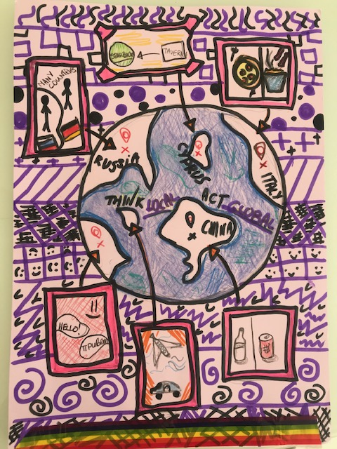
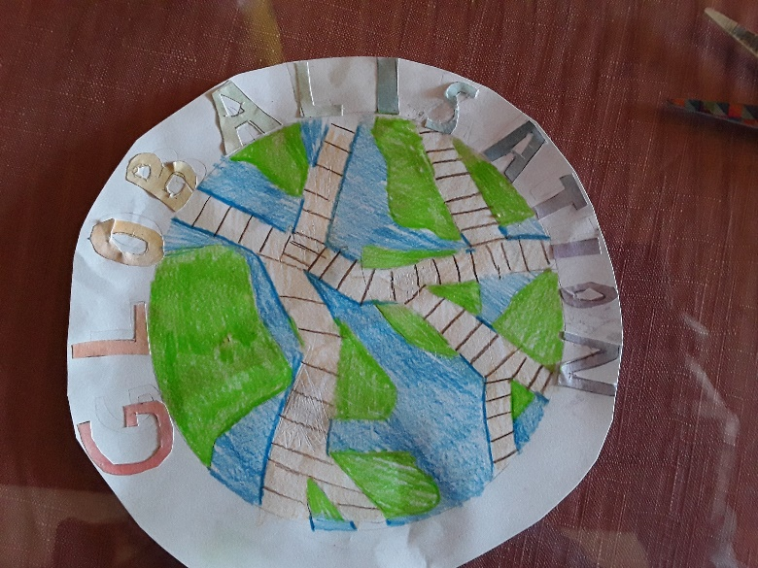
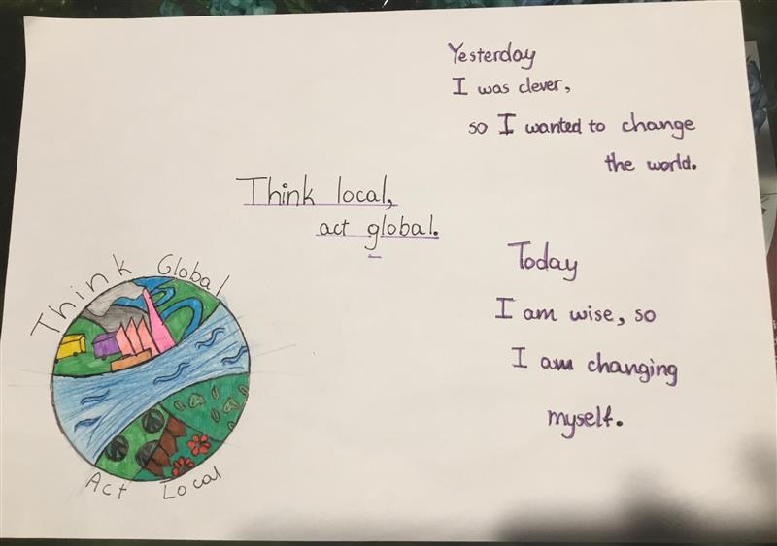

Katerina Vasiliou, Beate Kucere and Michaela Pylioti Y6 Junior school students

