‘’Once upon a time … we were told otherwise…’’

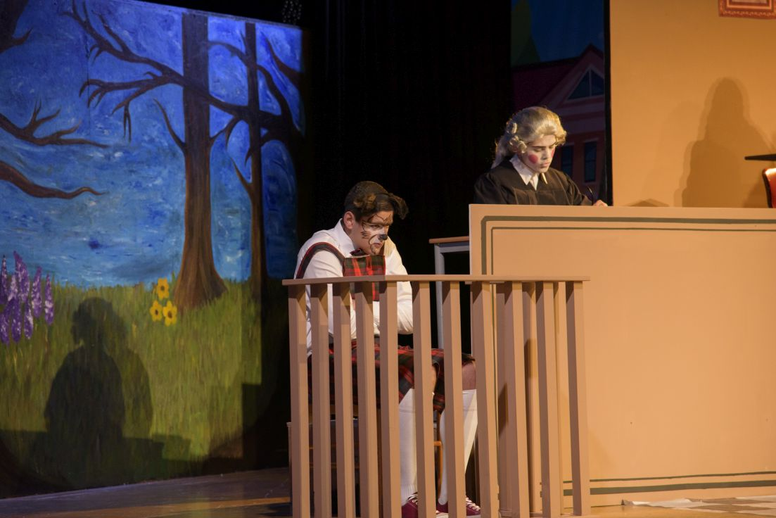
On 12th of February we had the opportunity to see the theatre that high school students’ theatre club performed. The play called “once upon a time… we were told otherwise…’’and different characters from many fairy tales appears in order to create an amaising story. The play was so funny with extremely beautiful costumes. Finally, the proceeds of the show they used it to support the social service institution of Holy Diocese of Constantia – Famagusta.
