“PEDAL FOR HEALTHY LİFE” EVENT İN ALTINTAŞ
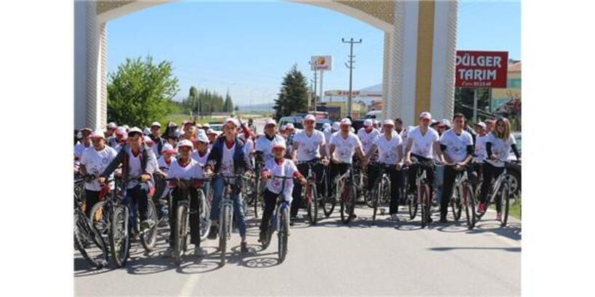

“Pedal for healthy life” event, which was participated in the district protocol in Altıntaş district of Kütahya, was organized.
Altintas National Education Director Numan Tanrıkulu, in the statement about the event, said, "As Altıntaş Mustafa Kemal Secondary School, our school's physical education teacher İbrahim Ilık under the management of our school principal Tuba Sinan underlined the project for healthy life. We organized a bicycle tour across the district with the slogan "pedaling"The bicycle tour started from the Şehit Sancaktar Gate and continued for 4 kilometers.

The effects of Active life on our health are important, so we organize bicycle tours for our students to adopt a Active lifestyle.
Active lifestyle should be made a habit. If the physical activity habit is not made into a regular program, the body systems that are regulated with the activity for a certain period of time begin to quickly lose the beneficial effects that occur after the activity is stopped.

Authors:Rabia UYGUR
Şerife KARAAĞAÇ

