REMOVE THE BARRIERS OF THOUGHTS

In the project carried out with the aim of giving information about the reasons of the differences between the individuals with special needs who attend the special education class in our school and some features of the students with special needs.
In the special education class, activities were held in our school to provide information about how we study with these students and to enable students with normal development to empathize about how people with special needs feel.
It is aimed that the students with normal development will have a positive attitude in communicating with the students of both mainstream students and special education class in our school and provide them with a positive discrimination.
The students were asked to write a balloon with an end-cut balloon for the individual who could not use his hand due to his spastise.
2-In order to understand the students who do not have hands, they were asked to write by keeping the pens in the mouth and keeping the hands behind.
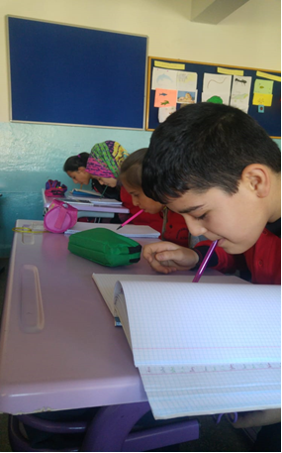
3-For the visually impaired, the Braille alphabet (by putting the pins in the foam) and “parents” were written and the symbols of these letters were shown on the board and students were asked to read with their fingers and eyes closed.4- To understand dyslexia (it is a mental process), it is stated that the text written on the board is reflected in the mirror and that the people who see it in the mirror are seen by dyslexic people.

Authors:Necati BİNİCİ
Özlem ÇAY

