We left from Perugia at 8:00 am and after 3 hours we’ve arrived at Arpino, a little verdent town where was born Marcus Tullius Cicero. Sitting in the garden of his luxurious “villa”, we were ready to meet the famous politician……
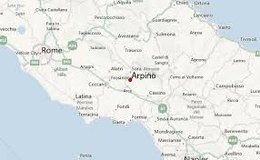
- Good Morning Mr Cicerone, it’s a pleasure to know you and an honour to interview!
- Goodmorning, the pleasure is mine! I love speaking with young students! We can start when you want!
- Can you say your name?
- Hi, I’m Marco Tullius Cicero
- What have you done in your life?
- I’m a Roman philospher, a politician, a lawyer, an orator,a political theorist. I was consul and constitutionalist.
- What family do you come from?
- I come from a wealthy municipal family of the roman equestrian order.
- How were considered in your times?
- I was widely considered one of the greatest orators and prose stylists in Rome.
- Have you influenced literature?
- Yes! I have influenced Latin language, but also European language up to the 19th century with my prose.
- Do you are inspired by greek philosophy?
- Of Course! I also introduced the Romans to the chief schools of Greek philosophy and I created a Latin philosophical vocabulary.
I tried to use philosophy to achieve my political goals. In an age when philosophy was still very much centred on Greece, I translated the major Greek works through summaries of the beliefs of the Greek philosophical schools of the times.
- What are the primary philosophical schools of the times? They’re Skepticism, Stoicism and Epicureanism. The Eclecticism is one of the most popular schools in Rome. Actually I’m an eclectic!
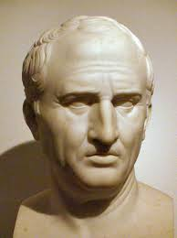
- Have you learned a lot from these schools?
- Yes! I was well acquainted with all these schools, infact I had teachers in each of them at different times of my life, and I am the source of much of your knowledge about these schools.
- We also know that you’re considered as a Western philosopher, aren’t you?
- Yes, I’m! But I did not actually contribute to the discipline so much.
- How are your works written?
- All my works are written in outstanding Latin prose.
- What are the most important philosophical works that you wrote?
- My philosophical works are mostly based on stoic phylosophy. I can suggest you to read “De amicitia” (On friendship), “De senectute” (On old age); “De officiis” (On duty) and “De natural deorum” (On the nature of the Gods)!
- Did someone reuse your works?
- Yes, Petrarch rediscovered my writing in the 14th century, and they paved the road to Renaissance. Augustinus, when he was 19, started to love philosophy reading my Ortensius; and Copernicus, reading my works, found out Iceta from Syracusa, Filolaus, Eraclides from Ponto and Ecfantus the pitagoric and learned about eliocentric theory!
- Wow! So we can say you contribute at the Copernicans Revolution! And can you mention some other philosophers you influenced?
- Yes! My writings had great influence on the Enlightment philosophers too. I mean Montesquieu, John Locke and David Hume.
- Thank you Cicero, it was a pleasure to meet you. We really learned a lot of thing!

