NIGHT AT THE MUSEUM 1

Pre-viewing task – Answer these questions:
1 What famous museums are there in our town? What can you see there?

2 What do you think – is a job in a museum interesting or boring? Why?

3 Would you like to stay one night in a museum? Why / Why not?

While-viewing task – Fill in with the right words.
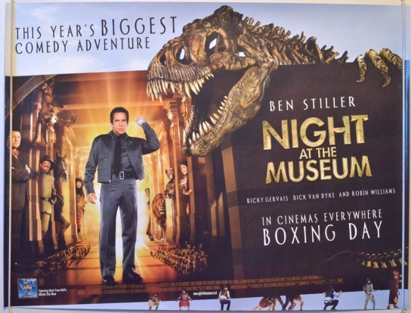
Larry wants to see __________ son more.

Nicky lives with his mother and her new __________.

Erica is __________ mother.

Don is rich and has a __________ job.

Rebecca __________ at the Museum of Natural History.

Dr. McPhee __________ the head of the Museum of Natural History.

Gus, Cecil and Reg are the night __________ - they have a big secret.

Post-viewing task – Match the characters with their descriptions.

Theodore Roosevelt was...

Octavius was...

Sacajawea was...

Attila the Hun was...

Jebediah Smith was...

Pharaoh Ahkmenrah was...
...a famous cowboy.
...a Native American woman – she took some of the first Europeans to the Pacific Ocean.
...an Egyptian leader – he died when he was very young.
...a President of the USA.
...the strong leader of a very big part of Asia.
...a famous Roman leader.

NIGHT AT THE MUSEUM 1 TEST

1 Think about the film, and name:

- 3 animals from Africa _______________________________________
- a famous statue ___________________________________________
- 2 people from history _______________________________________
- a famous museum _________________________________________

2 Complete the sentences with these words: bones, threw, lock, coffin, guard, fight.

He __________ the ball to John.
Dogs like __________.
We __________ our enemies.
Did you __________ the door?
They put the dead body in the __________.
A __________ watches a building at night.

3 Answer these questions:

What happens at the museum at night?

What does the Easter Island Head want?

The dinosaur is alive! What must Larry do?

What does the monkey steal?

Why must Larry lock up the lions?

How does Larry run away from Attila?

Who saves Larry from the Romans’ attack?

