MINNA CANTH`s EXHIBITIONS AND LITERATURE

Type date here: 2/04/2020 | Yousif, Aatos, Joona, Iisa

by: Yuosif Algaber  MINNA CANTH`s EXHIBITIONS AND LITERATURE  MINNA CANTH HAD 10 EXHIBITIONS AND 7 LITERATURE  MINNA CANTH THE WORKERS WIFE  DRAMA (TYÖMIEHEN VAIMO)  THE spectacle WAS MADE IN 1885 WITH THE HELP OF MINNA CANTH AND ANNA LIISA, PENNED IN 1895 IN TYÖMIEHEN VAIMO. the main character Johanna is married to Risto, AN ALCOHOLIC WHO WASTE ALL HIS WIVES MONEY, JOHANNA CANNOT PREVENT HIM HER MONEY IS LEGALLY HIS, NOT HERS.  by: Iisa Kurki  -The short stories and stories were all held in Helsinki and there were a total of 7 stories.  -There were a total of 10 plays.  -They were from 1883 to 1895.  -Half of them were held in Porvoo and half were elsewhere.  -She has also translated three works.  -There are four biographies of her and two biographies in two parts. | by: Aatos  Minna Canth works so hard in somewhere because she dont have money.  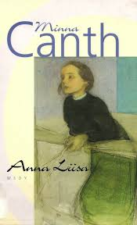 | by: Joona 5b  Here are a few Minnaś plays:  Sylvi: play in four plays (Helsinki, Otava, 1893)  Premiere January 23, 1893  The Spiritual Session: Clapping in One Act (Kuopio, Telén, 1894) Premiere 20.4.1894.  Anna Liisa: a play in three plays (Porvoo, WSOY, 1895) Premiere 2.10.1895  Away from Home: a single-act play (Helsinki, Otava, 1895) Premiere on November 8, 1895.  https://fi.wikipedia.org/wiki/Minna_Canth

IN MINNA’S SALON

Laura, Marwa, Juha, Eemi | 25.3.2020

Minna ja salonki  By: Laura 5b  Minna’s salon can provide cultural history and unique valuable material. | Minnan salonki  by: Marwa 5a  Minna’s salon contains nowadays the archive material of the author Minna Canth (1844 - 1897) in digital form.  Kuninkaan katu  by: Juha 5B  Minna’s salon is on Kuopio. Minna's salon was beautiful.there were a lot of guests.there was also lots of great room furniture.  Minna canth was born in Tampere but then she moved to Kuopio and that's where her salon was. | Minnan Salonki  By:Eemi Heinonen 5B  Author and merchant Minna Canth lived and ran her own shop in Kuopio next to the Cathedral on the corner of Minna Canth Street and Kuninkaankatu.  Minna Canth's combined study and living room - the "Minna´s Salon” - was both a writer's studio and a lively social center, attended by Finnish artists and cultural figures of the time.  On the wall is a painting by Kaarlo Vuori of Minna Canths daughter Hanna.

A Woman Who Changed The World

Minna Canth, Luukas, Sanni, Ivan, Taavi | 02.04.2020

Where Minna Canth contributed by:Luukas Hallikainen  Minna wished her children a good future. Minna significantly changed the position of drunks.Minna's plays were largely related to the position of women, drunks and poor.  Theater house on Väinolänniemi.  Photo by: Sanni Strömberg  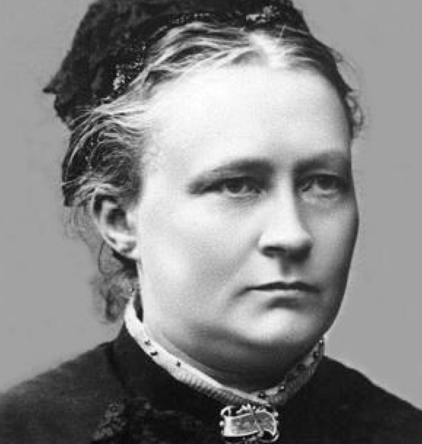 | Minna spoke to the audience photo by:Luukas Hallikainen  Minna Canth and plays  by: Sanni Strömberg  Minna Canth published a total of ten plays, seven short stories, as well as megazine articles, speeches and stories.  Canth also directed plays.  Photo by:Taavi A | Poor drunk  Photo by:Luukas Hallikainen  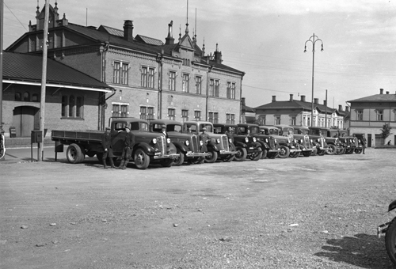  Tampere Minna’s time  Photo by: Luukas Hallikainen  Minna Canth and feminine  by: Ivan Semenchukov  From her first press stories, Canth wrote for the status of women and social change. Among other things, the education of girls and the extension of women´s rights were important to Canth.

Page 1 | Continued on Next Page

Minna Canth | 02.04.2020

Life of Minna Canth
Minna Canth was a Finnish writer and social activist. Her work addresses issues of women’s rights. Minna borned to Gustaf Vilhelm Johnsshon and his wife ulrika.Minna canth was borned on 19 march 1844 and died in 12 may 1897.
Gustaf and ulrika had four children, minna included,of whom the eldest, adolf, died in inflancy.

Minna Canth

Page 2 | Continued on Next Page

