Eyes opens

Antti, Kerttu, Aatu, June, Anniina | Type Date Here

Minna Canth  by: Aatu Kettunen  Minna Canth 1874 first published journal article  Minna canth look  By: Kerttu  Minna Canth was active | Minna Canth becomes a reporter. Link to the video in the picture.  Minna Canth  BY: Antti Tolonen  Minna Canth was horrified at Equality, Poverty and the Status of Women, so she decided to do something about it. She started writing in the newspapers about the way she thought it was. | Minna Canth  By: Anniina  Minna Canth is a new journel reporter.She became editior in chief in 1874.

Page 1 | Continued on Next Page

Type Text | Type Date Here

Our daughter’s education
by: June
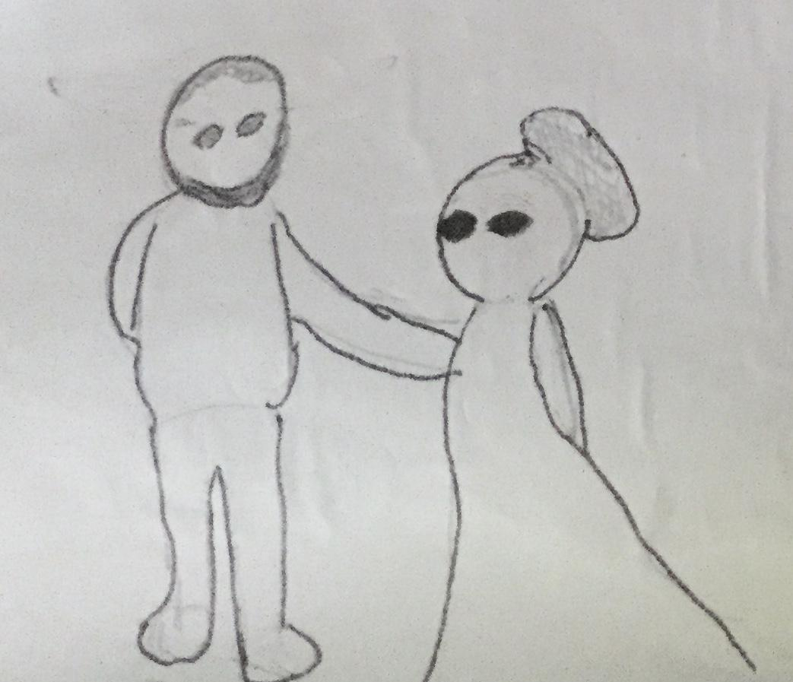  Minna Canth´s husband was in a newspaper business. | 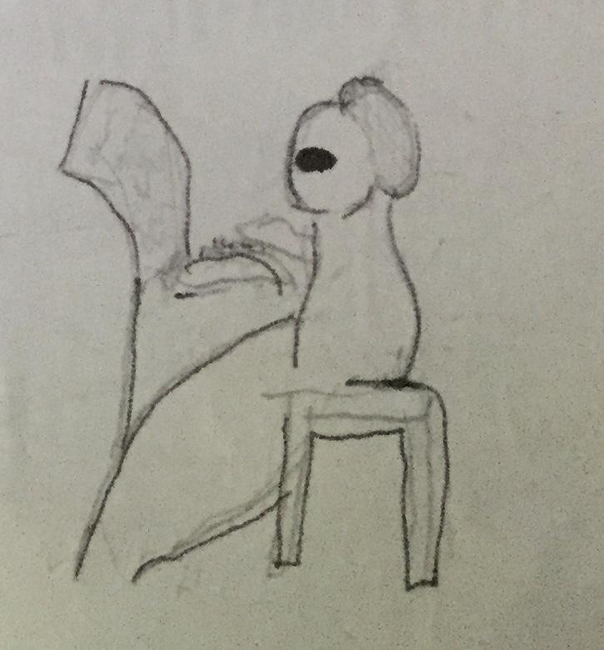  Minna Canth published her opinions in the newspaper.

And she was the first finnish woman journalist.  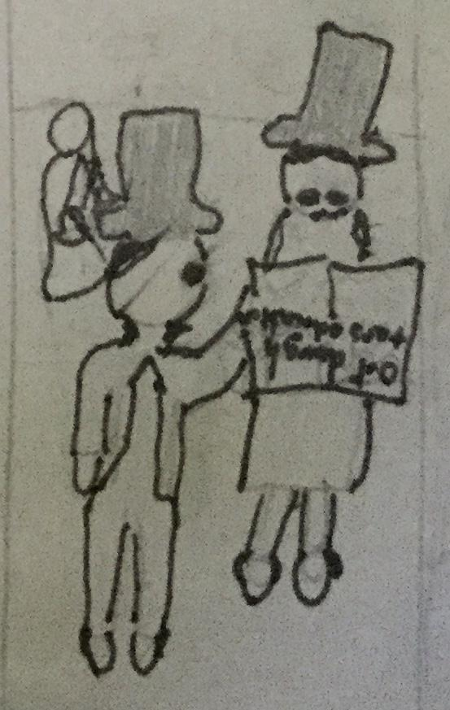 | 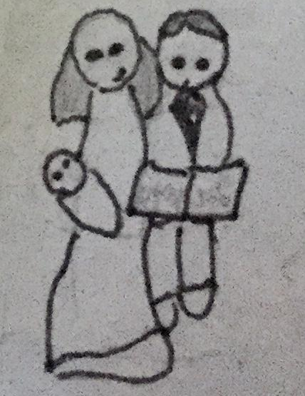  Her firs published article was ”Our daughter’s education”, in 1874.

