Creating food from leftovers - Poland

Quite often when we have some stale bread at home (which happens frequently because we love sandwiches in Poland) we make some croutons which we use with soups that we also love here :)
You take the stale bread (of course it can’t be mouldy), cut into pieces and then you fry the pieces on the frying pan with just a little bit of oil. You can also add some herbs if you like. And it’s ready.
Eliza
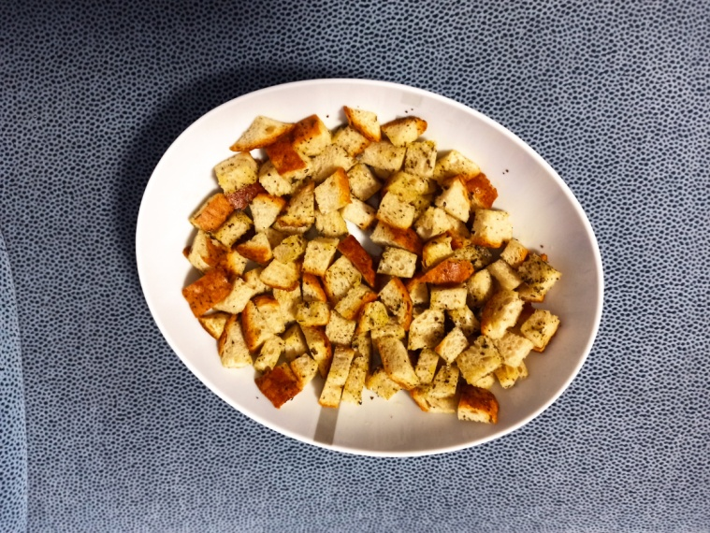
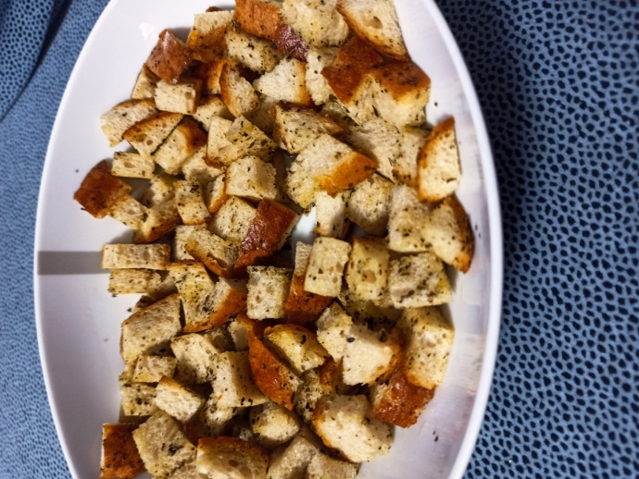

This time, I made vegetarian noodles from the food I found at home. The dish includes pasta, plain and cherry tomatoes, broccoli, peppers, black and green olives and tofu, of course, toufu can be replaced with meat. First, wash the vegetables thoroughly and cut them, then cook the noodles and fry the tofu with peppers and olives. add tomatoes, mix the sauce with the pasta and it's ready.
Wiktoria
