Evaluation of "Food Waste"

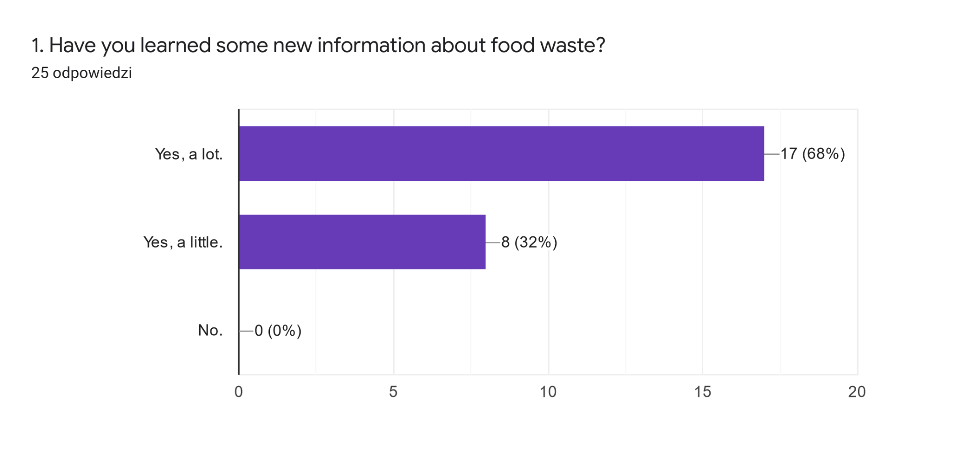

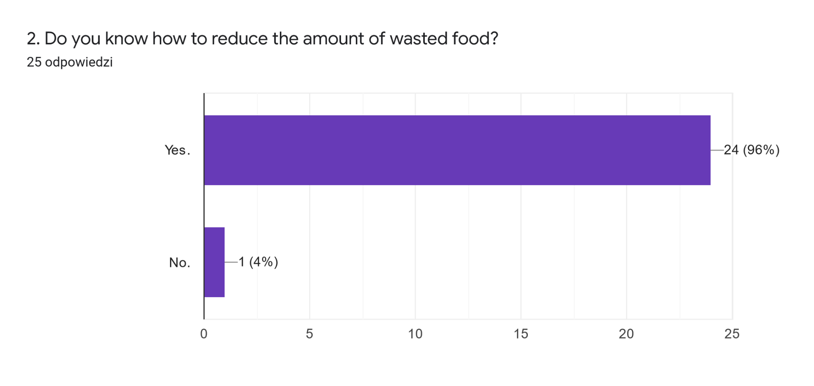

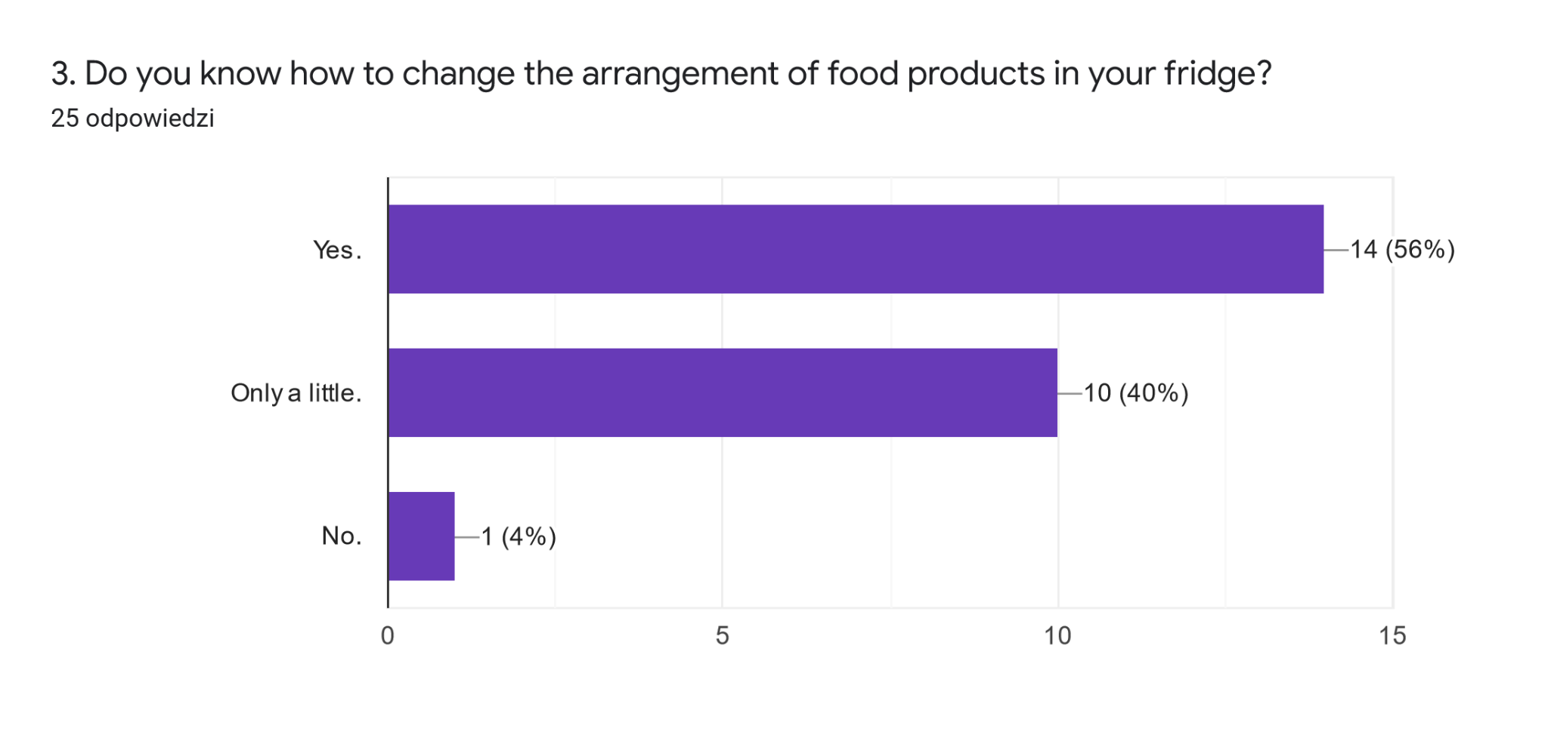
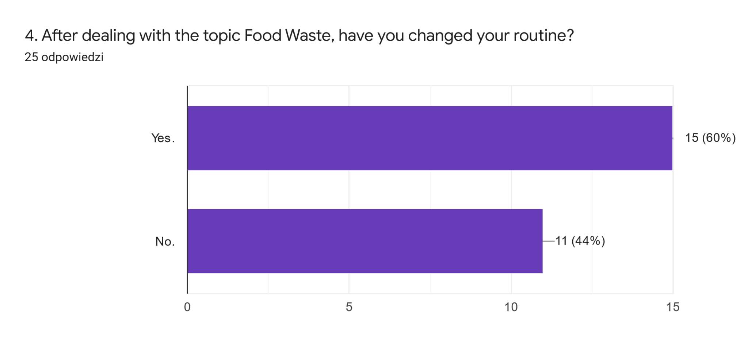
5. If your answer in the question about routine, was yes, please explain how you have changed your daily routine.25 odpowiedzi
.
-
no
I eat very much food, i don't have routine exactly
I tried not to waste much food
I wake up in the morning, I don't have breakfast, I go to school and at 11 am for recess I eat a sandwich.
Now, we are trying to reduce the amount of food waste in my house
I've started recycling and I've reorganized my fridge in a better way.
I changed the distribution of the products in my fridge. I cook with leftovers.
I changed my routine, I use food scraps in the new kitchen's machine
i havent
im trying to make dishes from the food, which id waste
I don't waste that much food, I make purchase lists
Yes
/
Yes we changed the position food
less food waste, different arrangemend of the fridge
fridge rearragenment, using all the food i buy

