ANALYSING COMPOST
POLAND

When we started working on the school garden, we also began working with our compost machine. With the help of some parents we managed to build a solid composter. We placed it next to our garden but under the tree to keep it moist and in a shadow.
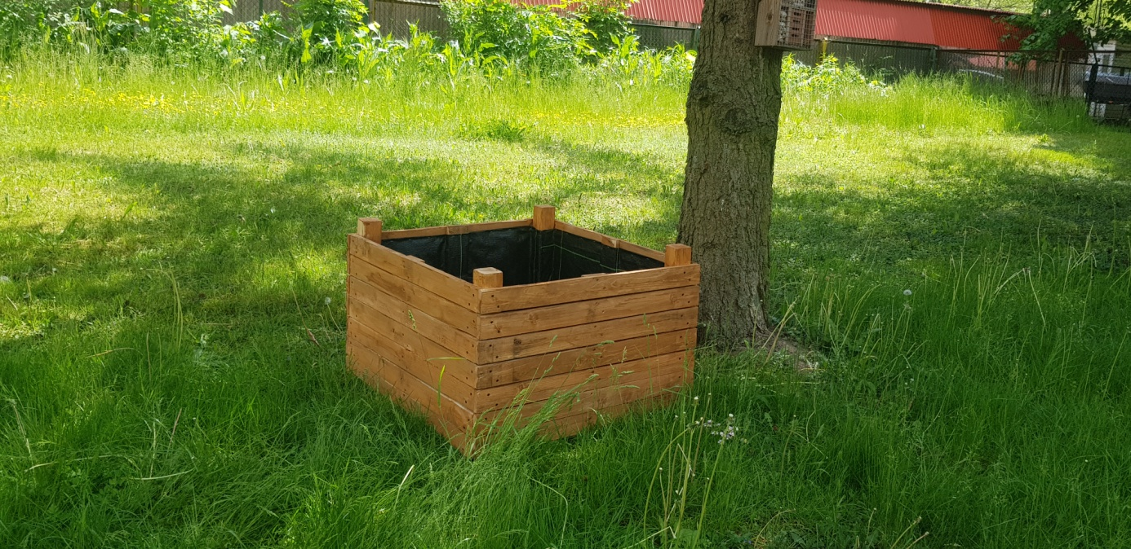

After a few months we collected the compost in order to have it analyzed. We took the samples to the classroom and watched it under the microscope.
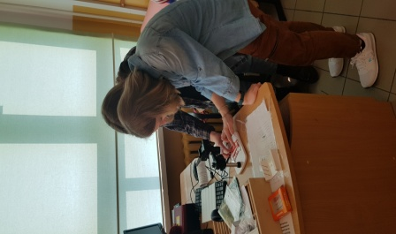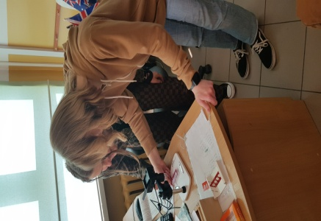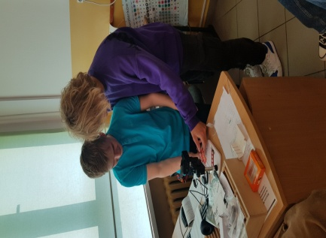

Students worked in pairs and followed the instructions given by Biology teacher. Everybody tried to find some small organisms in the samples. In the compost we found some worms, a few snails and a lot of rotten leaves, grass and some vegetables leftovers.

