Evaluation Questionnaire – MOBILITY IN POLAND

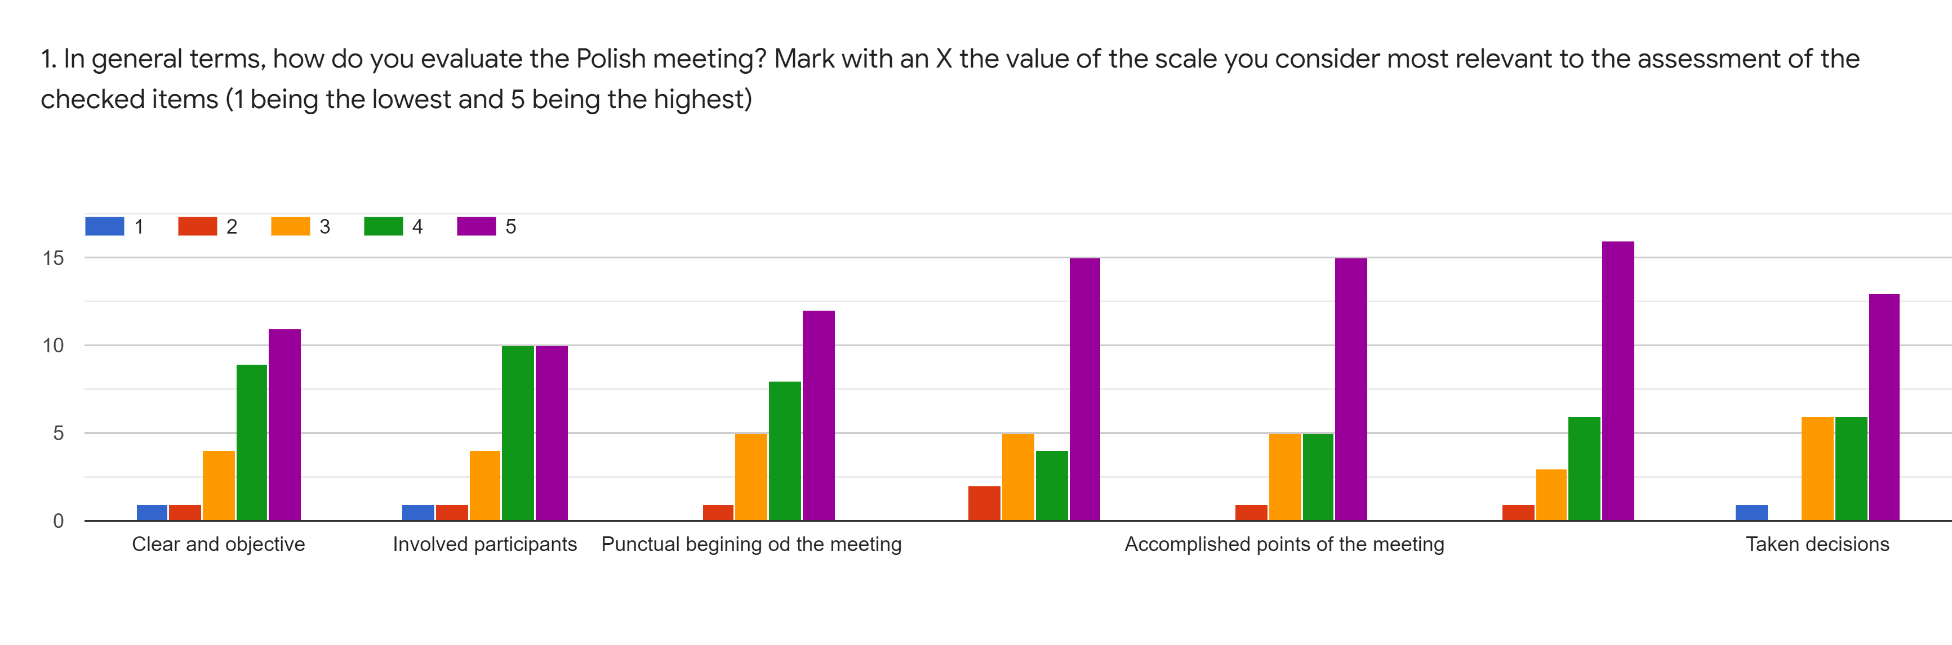
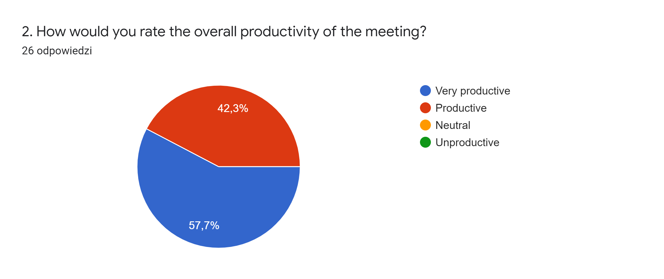

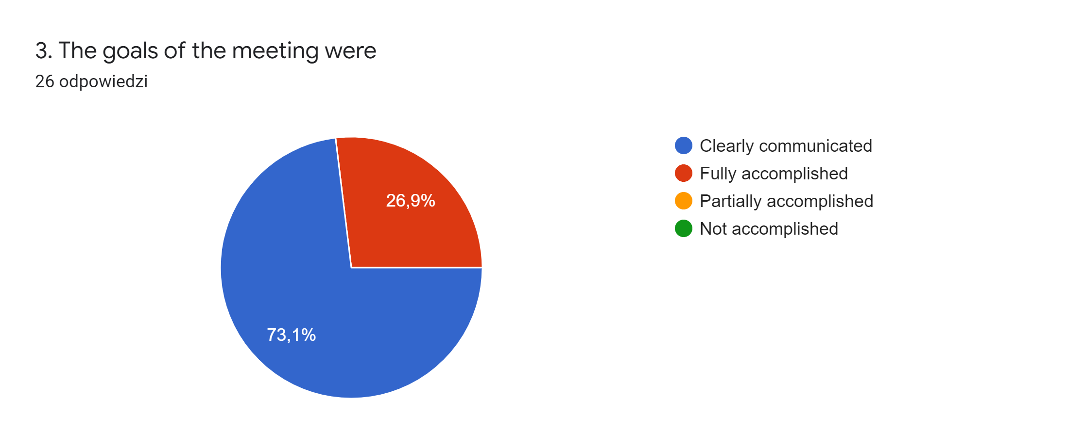

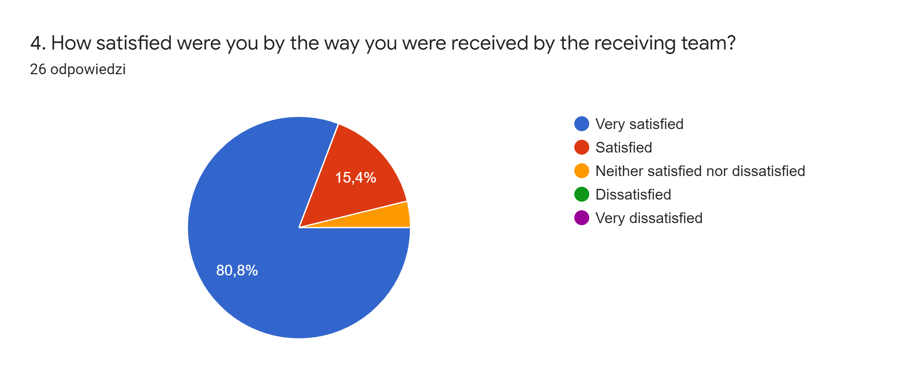

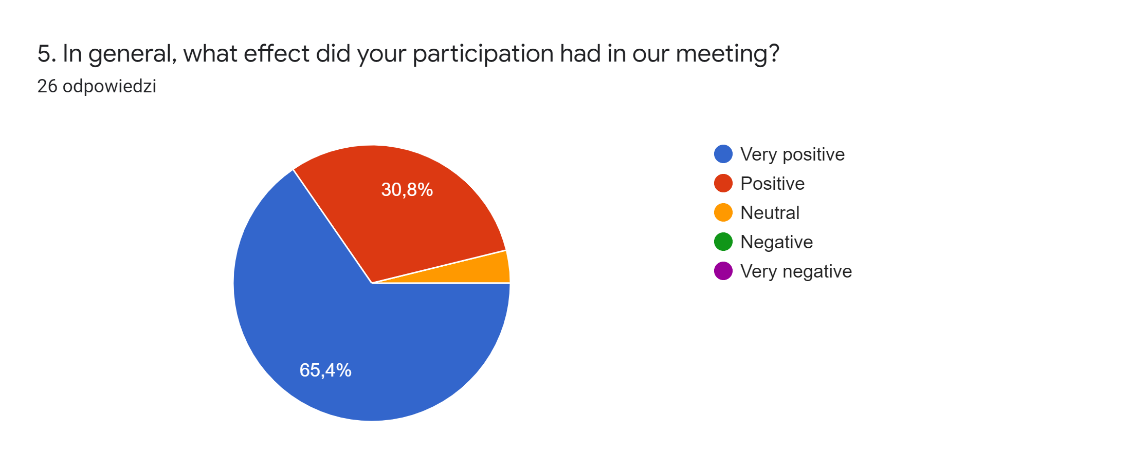

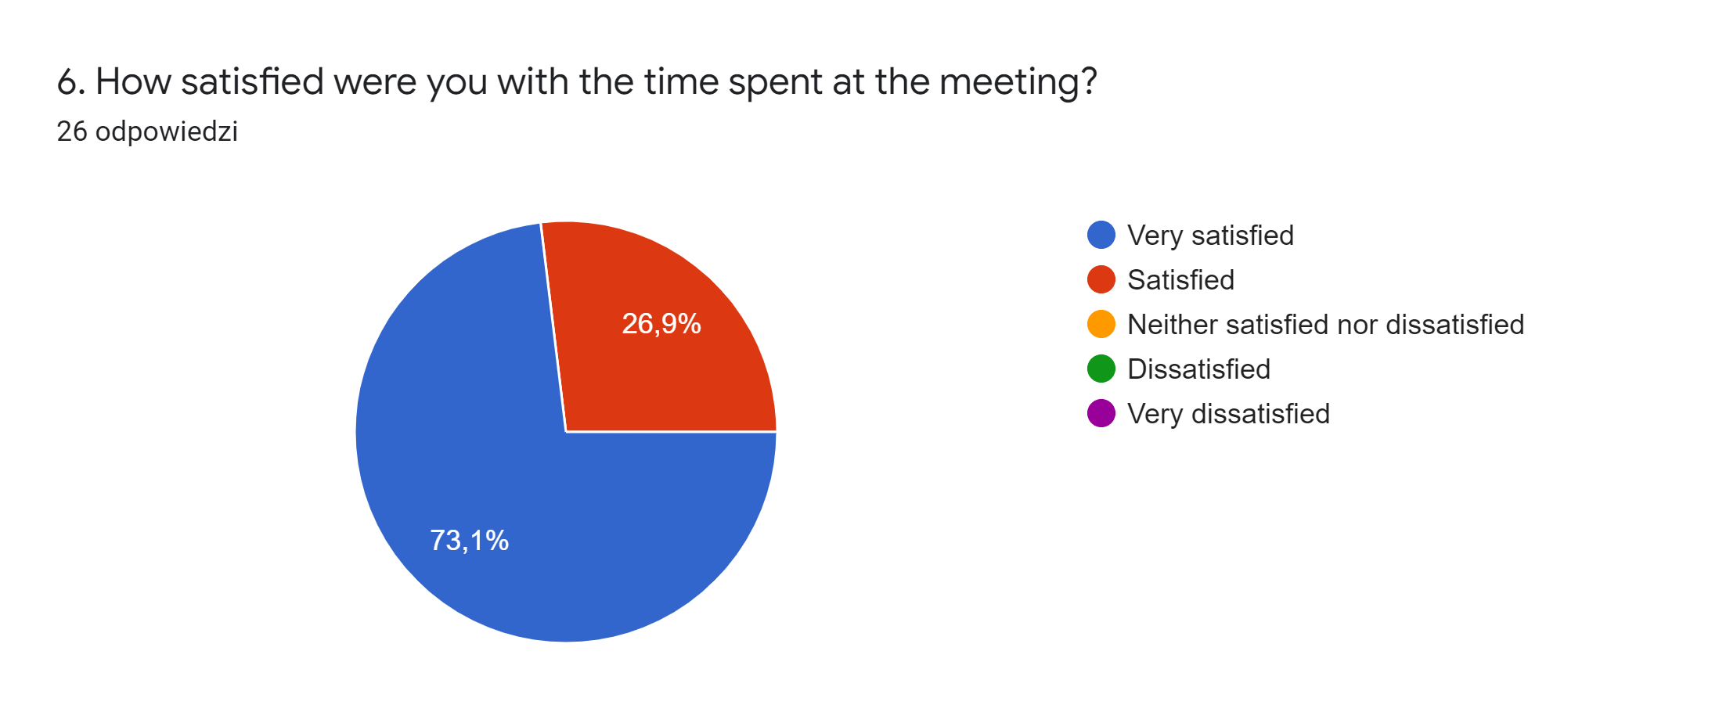

7. Is there anything specific you liked/ didn't like? If you didn't like something, what could we have done so that your participation in the meeting could have been more pleasant?10 odpowiedzi

I liked knowing new people
He aprés molt tan de food waste com inglés.
I just think that being in the house of the hosts would turn this experience richer
Not applicable
Not aplicabble
Not aplicable
not aplicabble
All members (teachers) of the host team have been very hospitable.
You have done everything very prudently and thoughtfully. Pupils and teachers enjoyed the activities - workshops we attended. Thank you very much, successful work in the future! Best regards.
What I liked the most was the visit to the old city, because the Polish students explained it in a clear way of understanding

