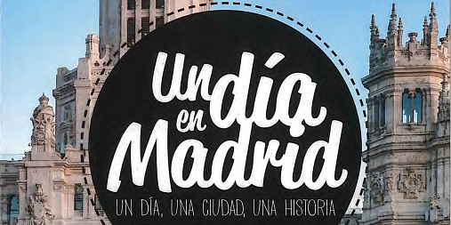
Imagine that you were to spend a weekend in Madrid, do some research to find 10 places you would like to visit and why. You can also read the suggestions in the forum in ETwinning.
1…………………………………………………………………………………………………………………………………………………………
2…………………………………………………………………………………………………………………………………………………………
3…………………………………………………………………………………………………………………………………………………………
4…………………………………………………………………………………………………………………………………………………………
5…………………………………………………………………………………………………………………………………………………………
6…………………………………………………………………………………………………………………………………………………………
7…………………………………………………………………………………………………………………………………………………………
8…………………………………………………………………………………………………………………………………………………………
9…………………………………………………………………………………………………………………………………………………………
10………………………………………………………………………………………………………………………………………………………

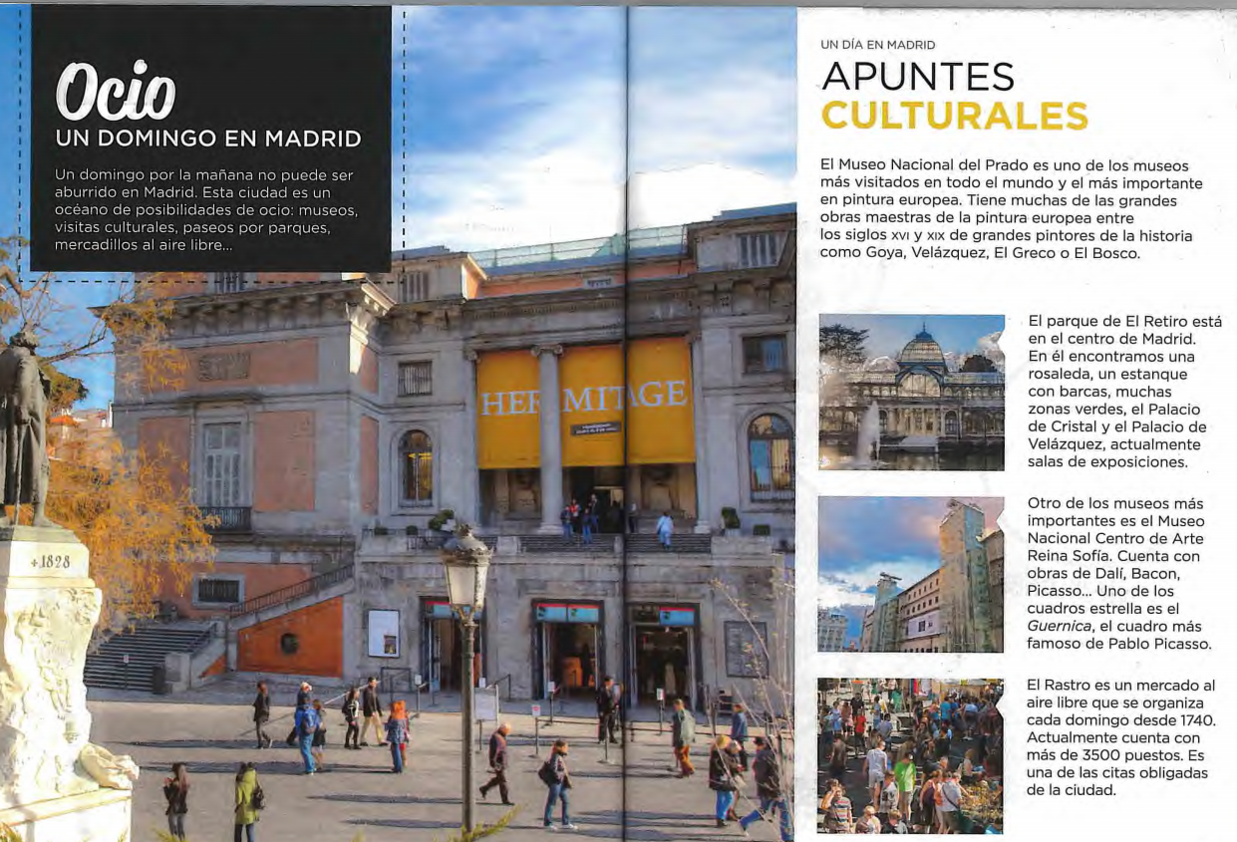
Adapt. From Un dia en Madrid, Editorial Difusión

