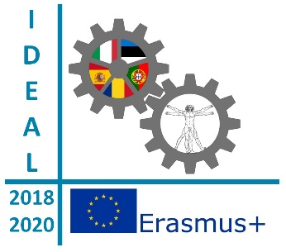
Creating highly customized maps to share with others and display.

Year 1 – Activity 1

Overview | My Maps is the best tool for having students share and work on the same maps together. Students from different partner schools can collaborate together to map out their schools, their neighbourhood, the region they live in and their country in Europe. Students can add different layers, descriptions, images (photos or drawings) and video. They can also calculate the distance between the partners school and see the itinerary from one to another. The goal is to use My Maps in a collaborative setting so that pupils can share information and get to know each other before they meet during LTTA.
Learning objectives | - Learn how to map one’s own school and the most relevant monuments and interest points in one’s town and one’s region in a collaborative way.  - Learn how to collect information about one’s own area  - Enhance the communicative skills in one’s own language and in English  - Strengthen the sense of belonging to the European Union  - Create or searching photos, drawings or videos  - Learn how to add pins to the Map  - Learn how to upload the information onto Google MyMaps.  - Learn how to draw an itinerary  - Learn how to read a map in order to get information about the partners’ schools.  - Improve the use of ICT
Times | PHASE 1  - 4 weeks – from the 17th September to the 12 th October  PHASE 2  - 2 weeks – from the 15 th to the 26 th of October
Resources | - Google MyMaps  - Books of geography, art and history  - Camera  - Videos, photos  - Internet
Steps | PHASE 1  - Ask students to research in groups as many information they can about their school (number of pupils, location, subjects taught), neighbourhood, town/city (inhabitants, point of interest, famous people), country (government, capital, language,currency, inhabitants, flag, climate, borders…)  - Let pupils write descriptions, make drawings, research photos and videos.  - Add a pin for each location,  - Add information to pins (title, description, photos, etc.)  - Let pupils choose the kind of pin they like (by colour or different icons)  - Let pupils draw lines or shapes over maps to help viewers interpret content easier  PHASE 2  - Pupils in group are asked to find information on Google Mymaps about their partners from the I.D.E.A.L. project according to a webquest.  - Each group creates a mind map with the information they have found and explain it to the other groups
Evaluation | Each group reports to the others the information they got about the partner they have researched about.
Assessment | Kahoot questionnaire
Methodology | - Project based learning  - Collaborative learning

