Personal Description
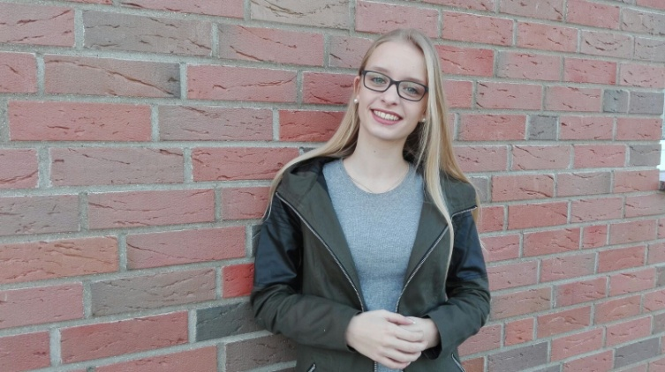

My name: Lea Wall
Birthday: 06.07.1999
My hobbies: play piano, go shopping, meet
Friends, paint, watch series
My future plans: after school I want to work in an office, travel a lot, have an own family with a small dog
What I expect of the project: I want to learn something about your culture, see new places, improve my language skills and have a lot of fun
Favorite food: Pizza, wrap, burger, sweets
Favorite series: Pretty little liars, teen wolf, game of thrones, prison break
& -movies: hunger games, Disney movies
Favorite music: many music styles but especially charts
Pets: a small dog
Allergy: cats, (dogs)

