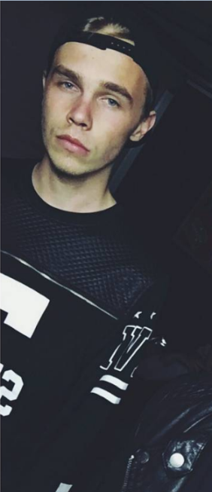
CLASS BG 11 (HOEXTER) , YEAR 2017/2017

MY NAME : Marvin Nolze
BIRTHDAY: 20.02.1998
MY HOBBIES: I play soccer and do some musicial stuff on my computer.
MY FUTURE PLANS: I try to do something in the musicial business for a living.
WHAT I EXPECT FROM WORKING TOGETHER WITH THE EXCHANGING SCHOOL: I’d just like to meet some cool new exchange students.
FAVOURITE FOOD: Burgers, Pizza, Lahmacun
FAVOURITE MOVIE: Fast and furious
FAVOURITE MUSIC: Edm
PETS: 2 cats

