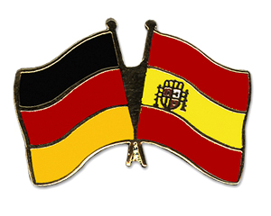 | Class BG 11 (Höxter)  School year 2017/2018  My profile | 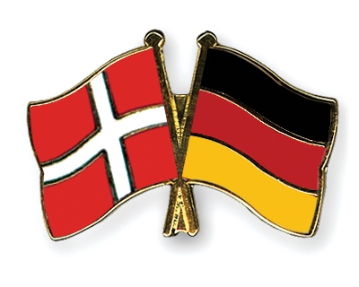

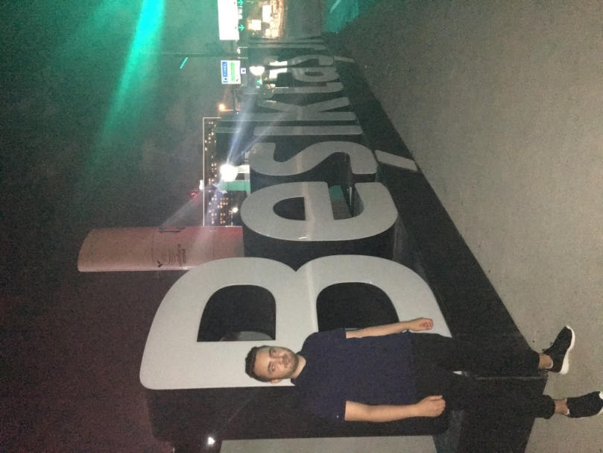
My name: Berk-Hasan Karaca
Birthday: 08.08.1998
My hobbies: play football, listen to music, play PS4
My future plans: I would like to be a policeman and I would like to graduate with grades
What I expect of the exchange: I hope to increase my English skills and to learn about different cultures.
Favourite food: pizza, lasagna and Sushi
Favourite movie/serie: Fast and Furious, Prison Break and The Walking Dead
Favourite music: German rap, American rap and Hip Hop
Additional information: I don’t eat pork.

