Personal Description

My name is: Daria Kröker 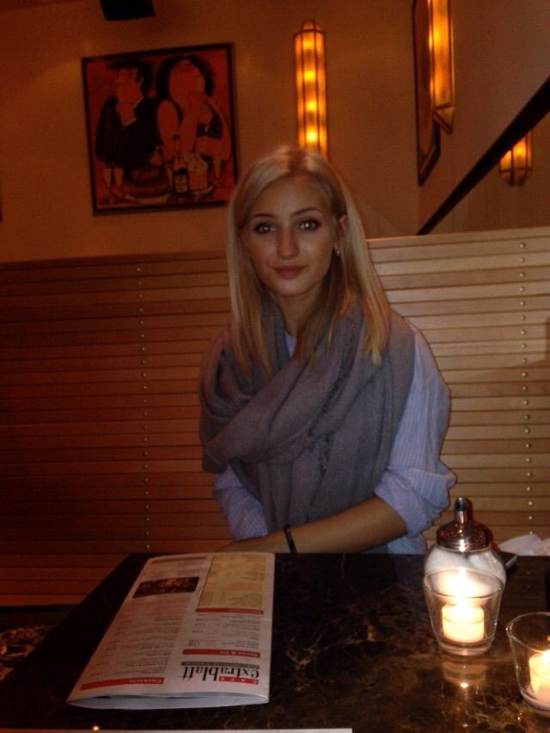
Birth date: 31.03.2000
My hobbys are: spend time with my friends and my . animals, Fitness, listen to music, cooking
Plans for the future: to get a good job, a family
with childs and animals

What I expect from
the project: I want to make good experiences,
get to know new friends and to
have a great time in Denmark
Favorite food: veggies, Pizza, Schnitzel, ice
cream, chocolate

Favorite series/
movies: King of queens, empire, Disney
movies
Favorite music: everything you can dance to
Pets: A cat and a dog
My allergies: Fish

