 | Class BG 11 (Höxter)  School year 2017/2018  My profile | 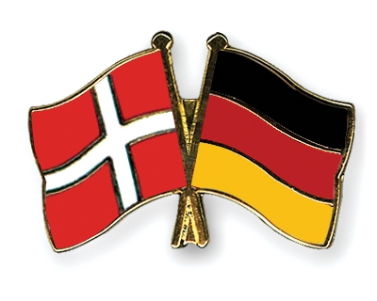

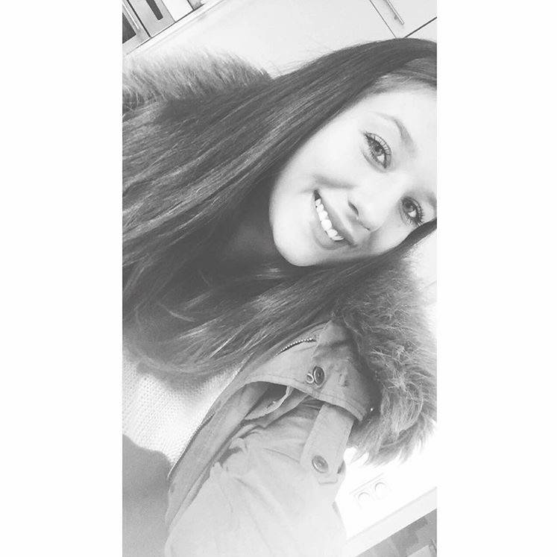
My name: Emma Grote
Birthday: 17.02.2000
My hobbies: Meet my friends, go to the gym
My future plans: I want to graduate in 2019
What I expect from the project: I hope to improve my english skills and to have better chances on the international labour market
Favourite food: Sushi
Favourite series: The walking dead, pretty little liars
Favourite music: Charts
Pets: A bird

