PROFIL
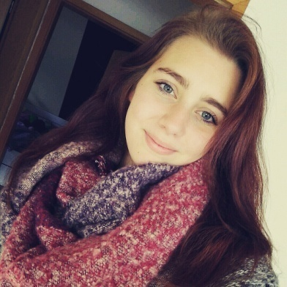
My name is: Chiara Orts

My birthday: 20.07.2000

My hobby: singing

My future plans: I want to finish school very well and I want to life in a house in a big city

WhatI expect from the project: I want to get speaking skills and I want to learn a lot about the cultures in other countries

Favorite food: Spaghetti, Pancakes, Donuts, Pizza

Favorite movie: fack ju göhte

Favorite music: new hits, charts

Pets: dogs and a rabbit

