Profile
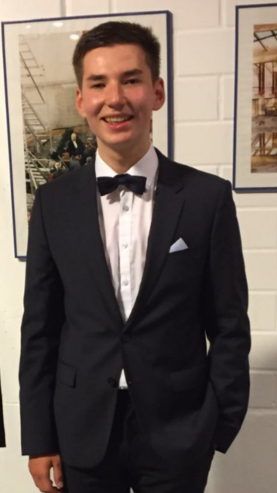
Name: Dennis-Leon Uslu
Birthday: 04.01.00
My hobbies: go to the gym, swimming, play comuter games
My future plans: graduate with good grades
What I expect from the project: obtain a certificate to have better chances at the European labour market
Motto of life: ayy lmao
Favortite food: pizza
Favorite movie: Star Wars

