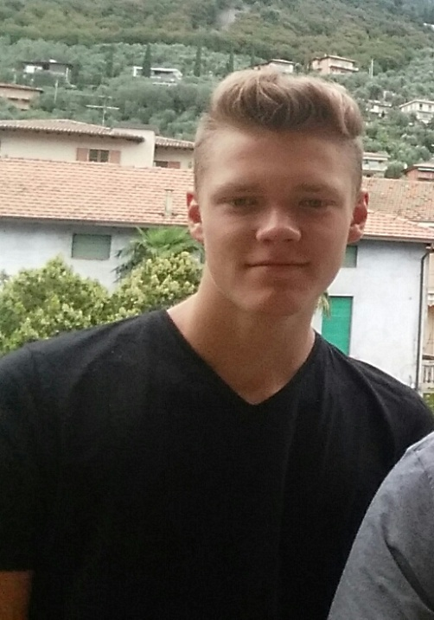
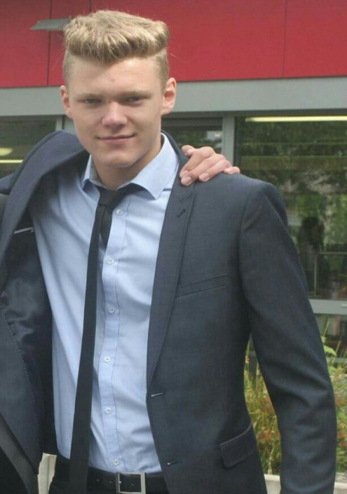
Profile

Name: Maximilian Manthey
Birthday: 23.02.2000
Hobbies: Playing football, motorsports
Futureplans: I want to graduate and get a nice job.
What I expect from the project: I want to improve my english skills and learn more about different countries.
Favorite food: Pizza
Favorite film: “Die Glücksritter”
Favorite school subject: Sports, Business economics
Pets: No Pets

