Personal Description
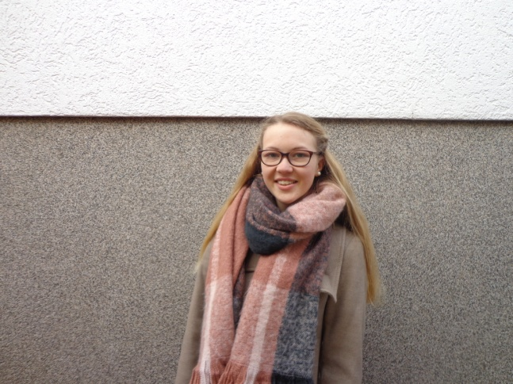

Name: Julia Jasperneite
Birthday: 20.04.2000
Activities: football, meet friends, watching movies
My future plans are: First of all I want to finish school and after that I want to travel a lot.
What I expect from the project: I want to improve my English and Spanish skills and learn something about your culture. I also hope to obtain a certificate to have better chances on the labour market.
Favorite food: Pizza, pancakes, donut, watermelon, sweets
Favorite film: Fack ju Göhte, Hunger Games
Favorite music: Charts
Pets: One rabbit

