 | Class BG 11 (Höxter)  School year 2017/2018  My profile | 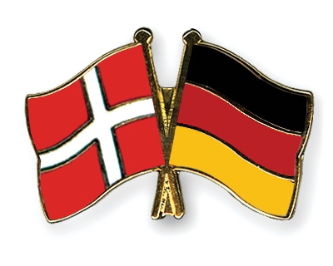

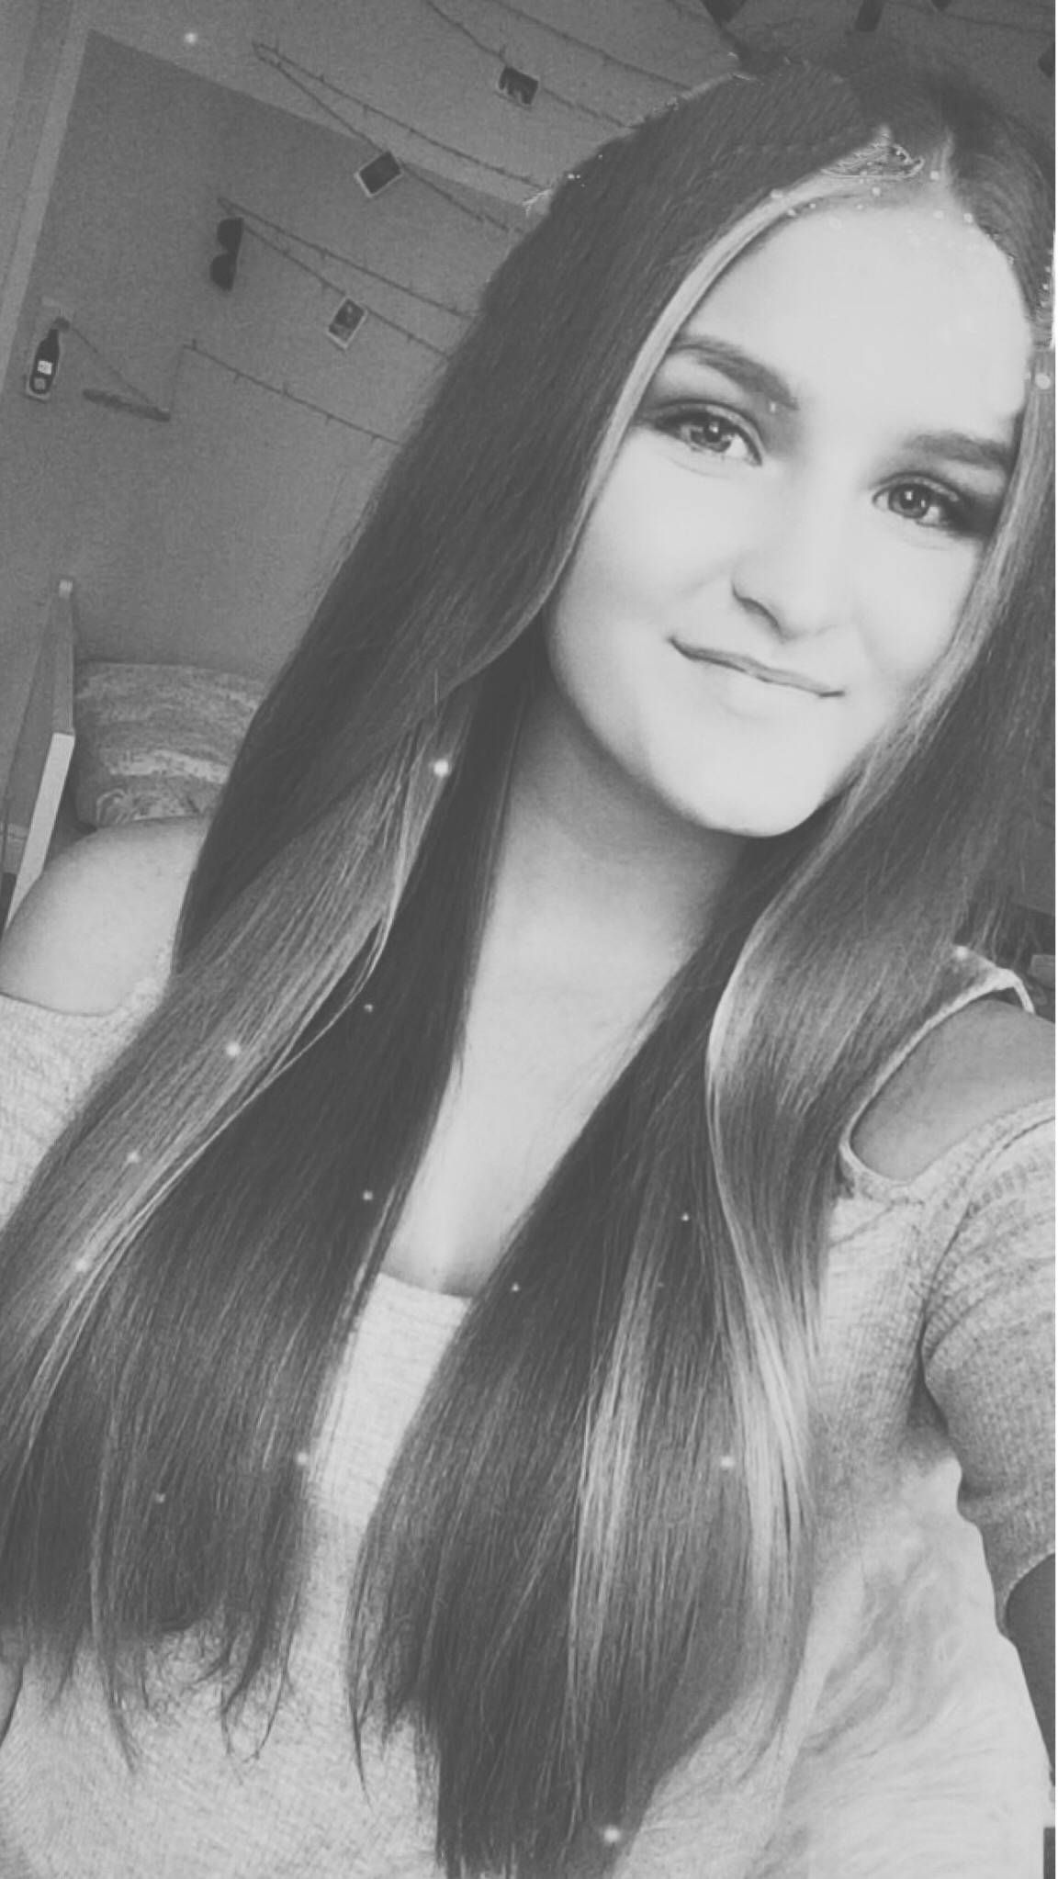
My name: Hannah Lotta Kruckenberg
Birthday: 24.04.2000
My hobbies: Meet my friends, go to the gym
My future plans: I want to graduate in 2019
What I expect from the project: I hope I can improve my english skills and I want to learn something about your culture.
Favourite food: Sushi
Favourite series: The vampire Diaries, The walking dead
Favourite music: It´s changes very often… mostly charts
Pets: A dog
My allergies: Cats

