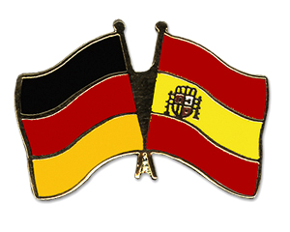 | Class BG 11 (Höxter)  School year 2017/2018  My profile | 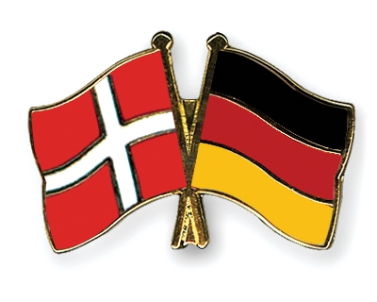

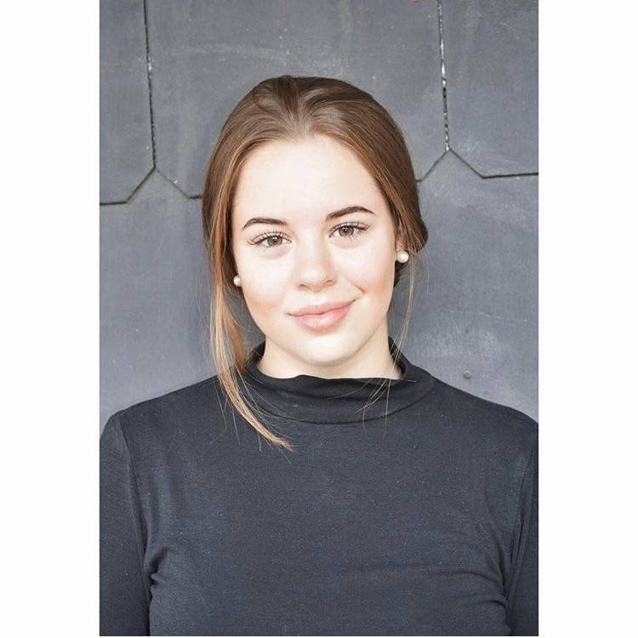
My name: Kimberly Hörnlein
Birthday: 22.05.2000
My hobbies: Meet my friends, go to the gym
My future plans: I want to graduate in 2019
What I expect from the project: I hope I can improve my english skills and learn something from other cultures
Favourite food: Fish
Favourite series: Prison break, pretty little liars
Favourite music: Charts
Pets: Two cats

