Profile
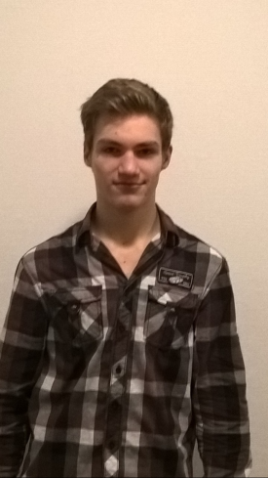
Name:
Carlos Nowinski

Birthday:
30.03.00

My hobbies:
do sports, play computer games

My future plans:
I want to graduate with good grades

What I expect from the project:
Obtain a certificate to have better chances at the European labour market

Motto of life:
Don’t give up just because of what someone said. Use that as motivation to push harder.

Favorite food:
Pizza

Favorite movie:
Star Wars

Favorite music:
Kygo

