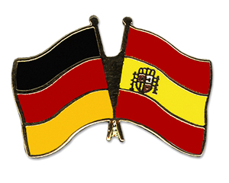 | Class BG 11 (Höxter)  School year 2017/2018  My profile | 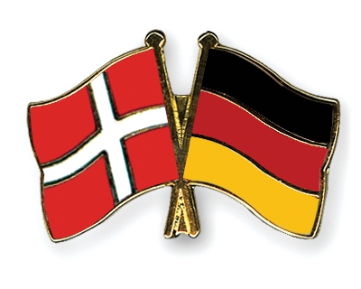

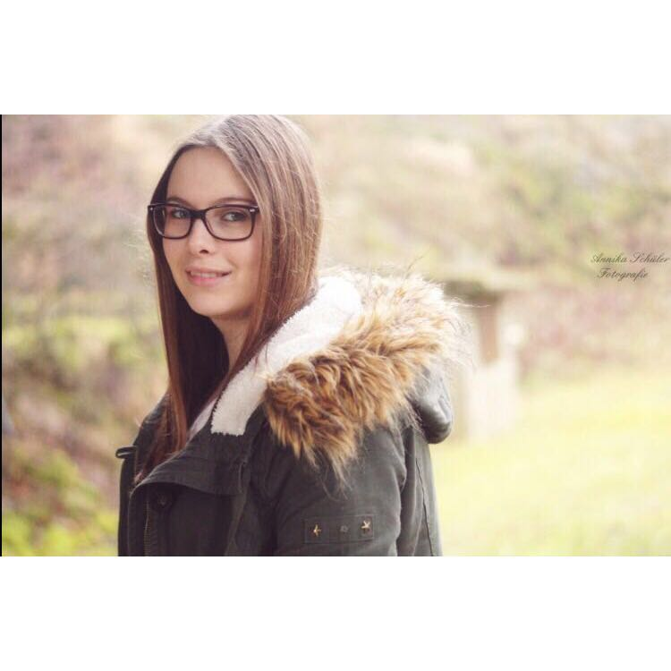
My name: Sina Krogmeier
Birthday: 02.01.2000
My hobbies: Meeting friends, watching football
My future plans: I hope to educate with good school marks and want to have a well paid job in the future
What I expect of the exchange: I hope to improve my English skills and I want to learn more about other cultures
Favourite food: Spaghetti
Favourite movie/series: The lucky one, Supernatural
Favourite music: Ed Sheeran, Ariana Grande, Demi Lovato

