 | Class BG 11 (Höxter)  School year 2017/2018  My profile | 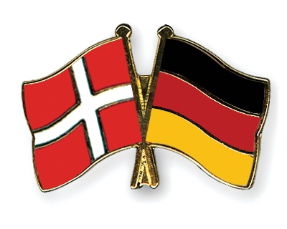

My name: Saskia Grüger
Birthday: 01.04.2000
My hobbies: playing football; meeting friends
My future plans: I hope to educate with great school marks
What I expect of the exchange: I hope that I can improve my English skills
Favourite food: Spaghetti; Salad
Favourite movie/series: Game of thrones; Vampire diaries
Favourite music: charts

