|  |  |  |
| --- | --- | --- |
| C:\Users\AZ\Desktop\LOGO.jpg | GWE1H  Erasmus + 2016-2018  "How to give the students skills and means on their way to the European labour market"  2016-1-ES01-KA202-025404 | Christmas questionnaire -  **Christmas traditions in comparison with the partner countries**  **Deadline: 10.12.2016** |
| Flag of Germany.svg | Flag of Denmark.svg | Flag of Spain.svg |

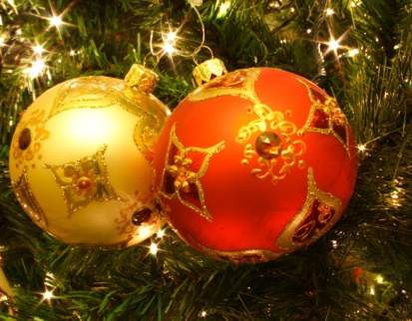 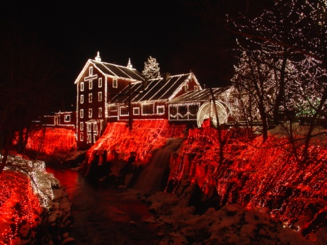

1. What do you enjoy most about Christmas time? Do you have any special customs in your country on this day?

We go on Christmas markets

1. What is the most important thing about the holiday for you?

The Christmas eve, the new year eve and the 3 wise men day (we receive presents that day)

1. Who do you celebrate Christmas with?

With family

1. Which are the main Christmas dates in your country?

24th (Christmas eve) and 25th of December and 6th of January

1. What does a typical day at Christmas look like at your home?

Friends and family come over start preparing the Christmas dinner watching TV, in the evening starting to eat and opening the gifts

1. What do you usually do on New Year´s Eve? Do you have any special customs in your country on this day?

Special dinner with friends or family.

We eat 12 grapes at 00:00 to receive new year

7. Does your town get decorated at Christmas?

Yes, churches, shops, Christmas markets and the houses are getting decorated

1. Do you usually decorate your home? How do you decorate for Christmas?

Yes, all sorts of decorations, chains of light, Christmas tree and Belén

1. How long do you leave your Christmas decorations up?

Until the 7th of January

1. Do you get/buy presents at Christmas?

Yes, but the spanish tradition present is the 5th (6th of January)

1. When do you start shopping for Christmas?

Its different, most people start shopping at the start of December and other, buy it in the last minute

1. What are the most important recipes?
2. Traditionally, who brings the presents in your country?

The 3 wise men

1. When do you open the gifts?

5th at nigh or 6th early in the morning

1. What is your favourite holiday memory as a child?

3 Wise men parade in my town

1. What is your favourite holiday tradition?

Eating the Christmas dinner

1. What is your favourite Christmas coral/song?

typical songs like "Last Christmas"  and "All I want for Christmas"

1. What is your favourite Christmas movie?

Our favourite movie is "New years eve in NY"

1. What kind of food do you usually have for Chistmas?

Lamb, sea food and recently turkey

Special soup made of meet and vegetables with meatballs

20.What is your Christmas wish?

Health for me and my family

1. When and how did you learn the truth about Santa and the three wise man? -

When I was 8 or 9

1. Do you feel that Christmas is too commercialized? Why or why not?

Yes, indeed

23.Do you like Christmas? Why or why not?

Yes, specially with children

1. Do you wirte mail, e-mail/a whatsapp message, Christmas cards? - Yes, we send Christmas cards by mail, send messages via whatsapp or e-mail

**Frohe Weihnachten! Merry Christmas! Feliz Navidad!** [**Glædelig**](https://browse.dict.cc/daenisch-deutsch/Glædelig.html)[**jul!**](https://browse.dict.cc/daenisch-deutsch/jul!.html)