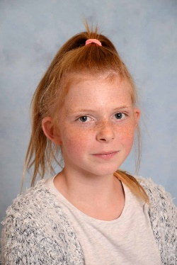
Hello, my name is Jamilia Bremer.

I come from Celle. My hobbies are drawing and climbing. I go to the secondary school Westercelle. I was born 29.10.2004 born .My favorite animals are cats, dogs and tigers. What I like is drawing because I can let my fantasy run free. What I do not like is to discuss or argue with my family. I have two sisters and a Half sister Kimberly (16), Natalia (10), Malin Jolie (Half sister)(5) .My parents are divorced for 10 years but I still have little contact with my Mother.

BYE

