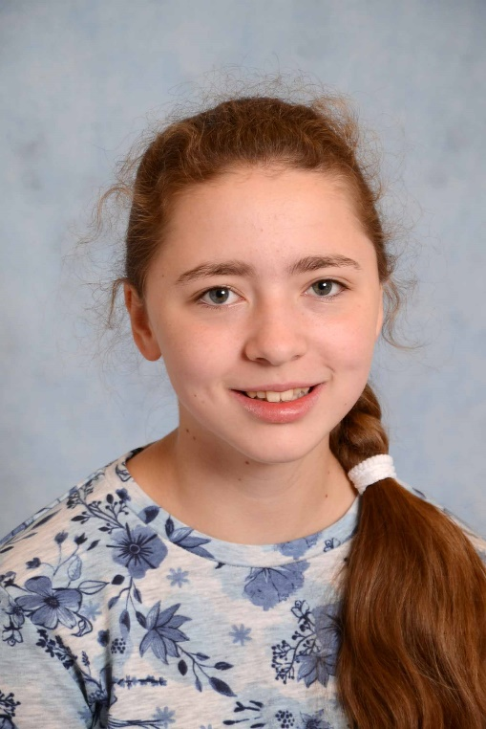
Hello
My name is Anna
I from in Celle That´s in Germany.
My birthday is on the 04.01.06
My hobbys are Bowling and Trampoline.
I like my friends and my family.
I don’t like fighting.
I love shopping,

