Historical Europe

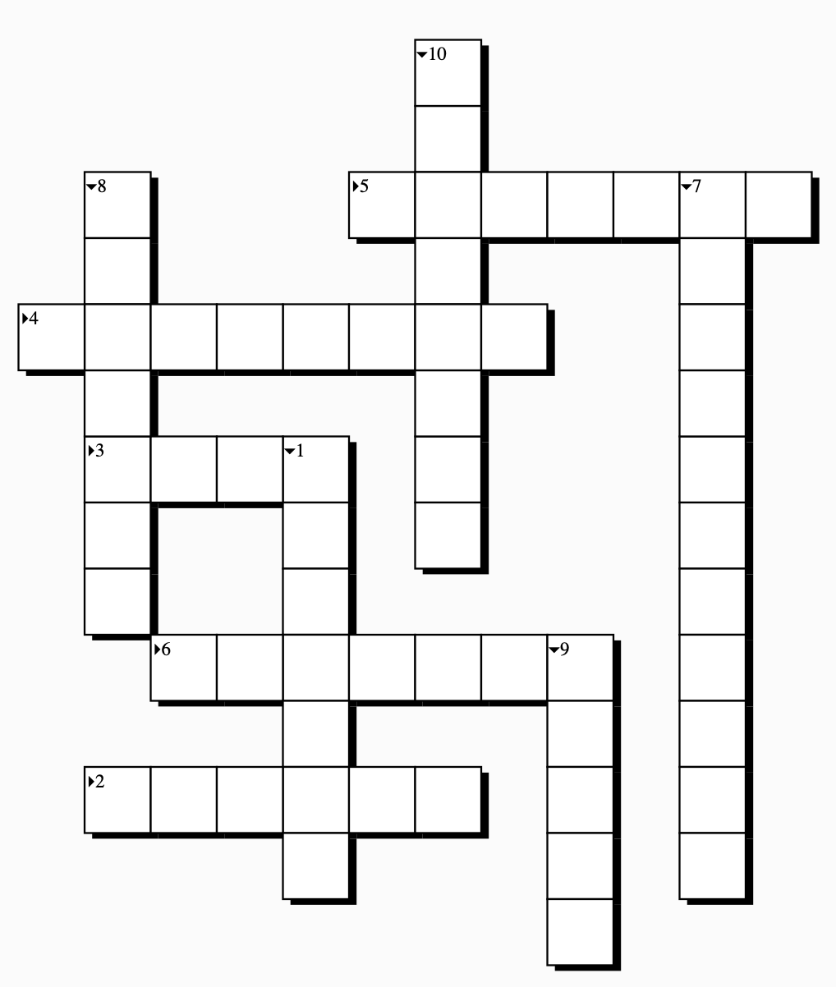
Find the ten places in Europe to solve this riddle!

- The country that has Stonehenge, Hadrian’s wall and the Tower of London.
- The country of the revolution of 1789.
- The city from which Julius Cesar ruled the “world”.
- Today’s name of the city once called “Constantinople”.
- In this country they sing “In Dublin’s first city, …”.
- The country in which you can find one of the European Parliaments.
- The country in which Rembrandt van Rijn was born.
- The country in which Wolfgang A. Mozart worked.
- The country that once was a fortress in the middle of the Mediterranean.
- The home country of a guy called Cristiano Ronaldo, one of the best footballers in history.

