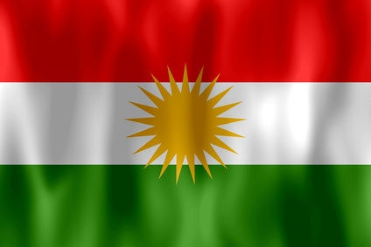
„Christmas“ for Yesids: ÎDA EZÎ

We do not celebrate Christmas but „Îd“. We celebrate three times. Before each îd we fast from Tuesday to Thursday. It starts on 04.12. and ends on 21.12. this year. The first Friday is called îda Sêsims, the second is called îda Xwudan and the main event what the most call the „Kurdish Christmas“ is called îda Ezî. On each holiday we celebrate with great dishes as duck, rice, lamb and sweets like Baklava or other sweets.

And of course we also get presents like all the other kids!

AUTHOR:ERKAN CIN (7d)

