POLAND
 | Picture | No.
library
football pitch
playground
cups
English classroom
canteen
smartboard
gym
patron, flag, emblem
school |  | 1

SPAIN
library
projector |  | 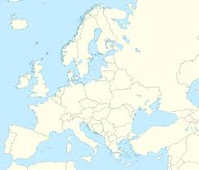
playground
cupboard
English classroom
slide
whiteboard
swings
canteen
sport equipment

GREECE
baskeboard court
playground
classroom
map
music room
green bin
computer room
canteen
cups

Where are we? Colour the countries in the map and match their names
Spain Poland Turkey Lithuania Greece

