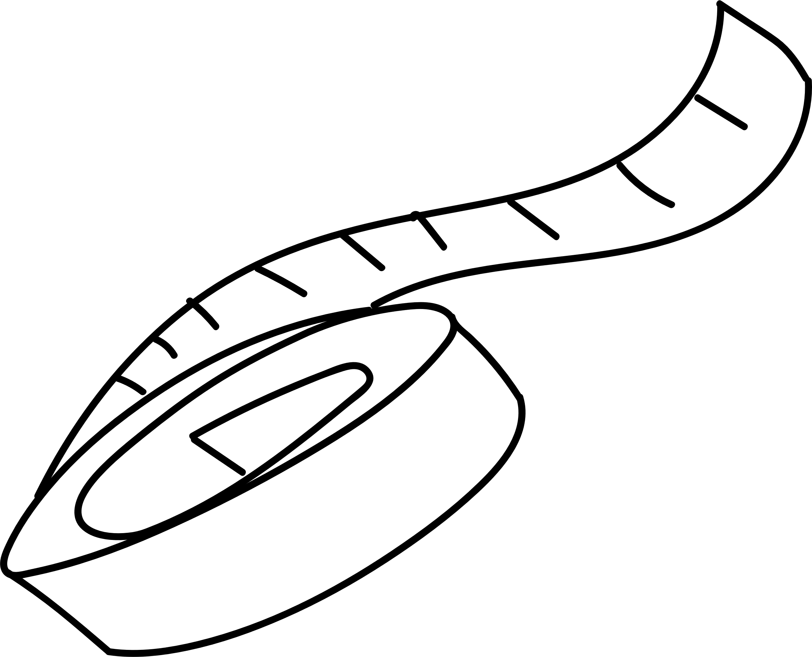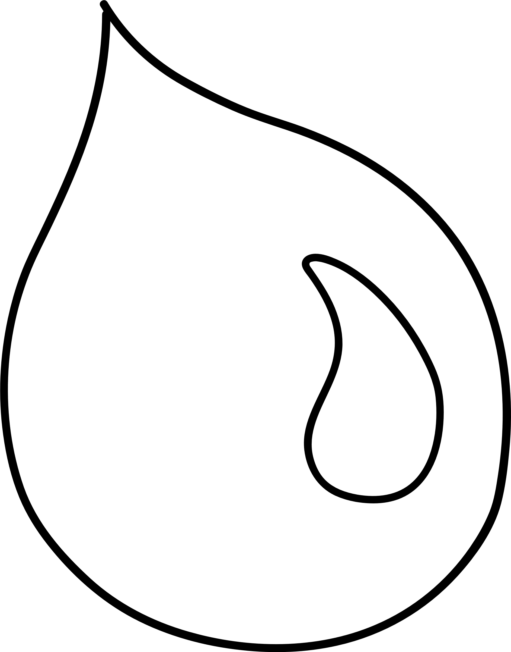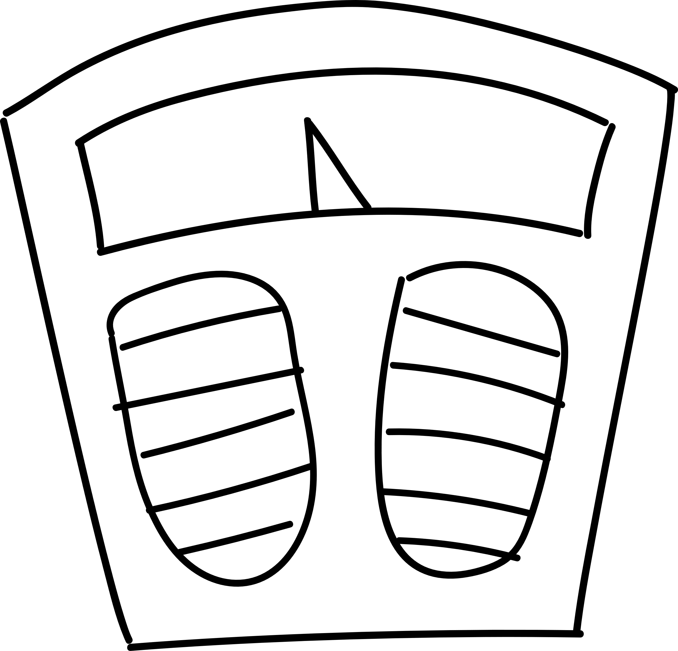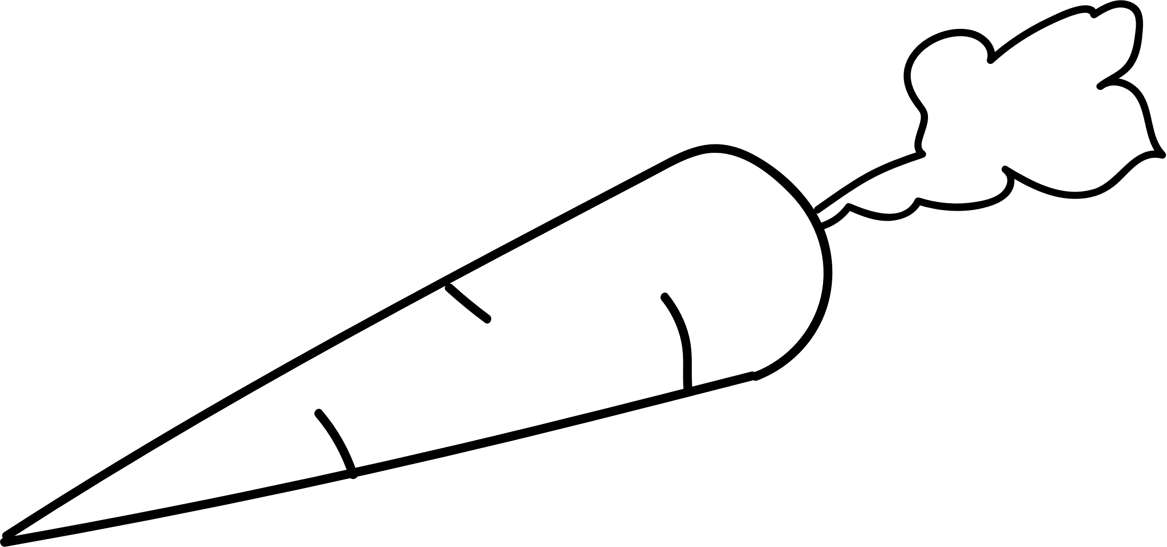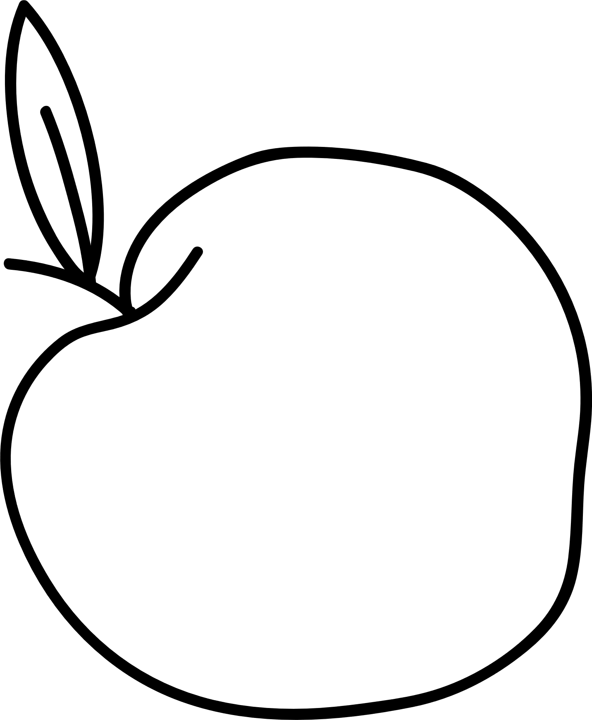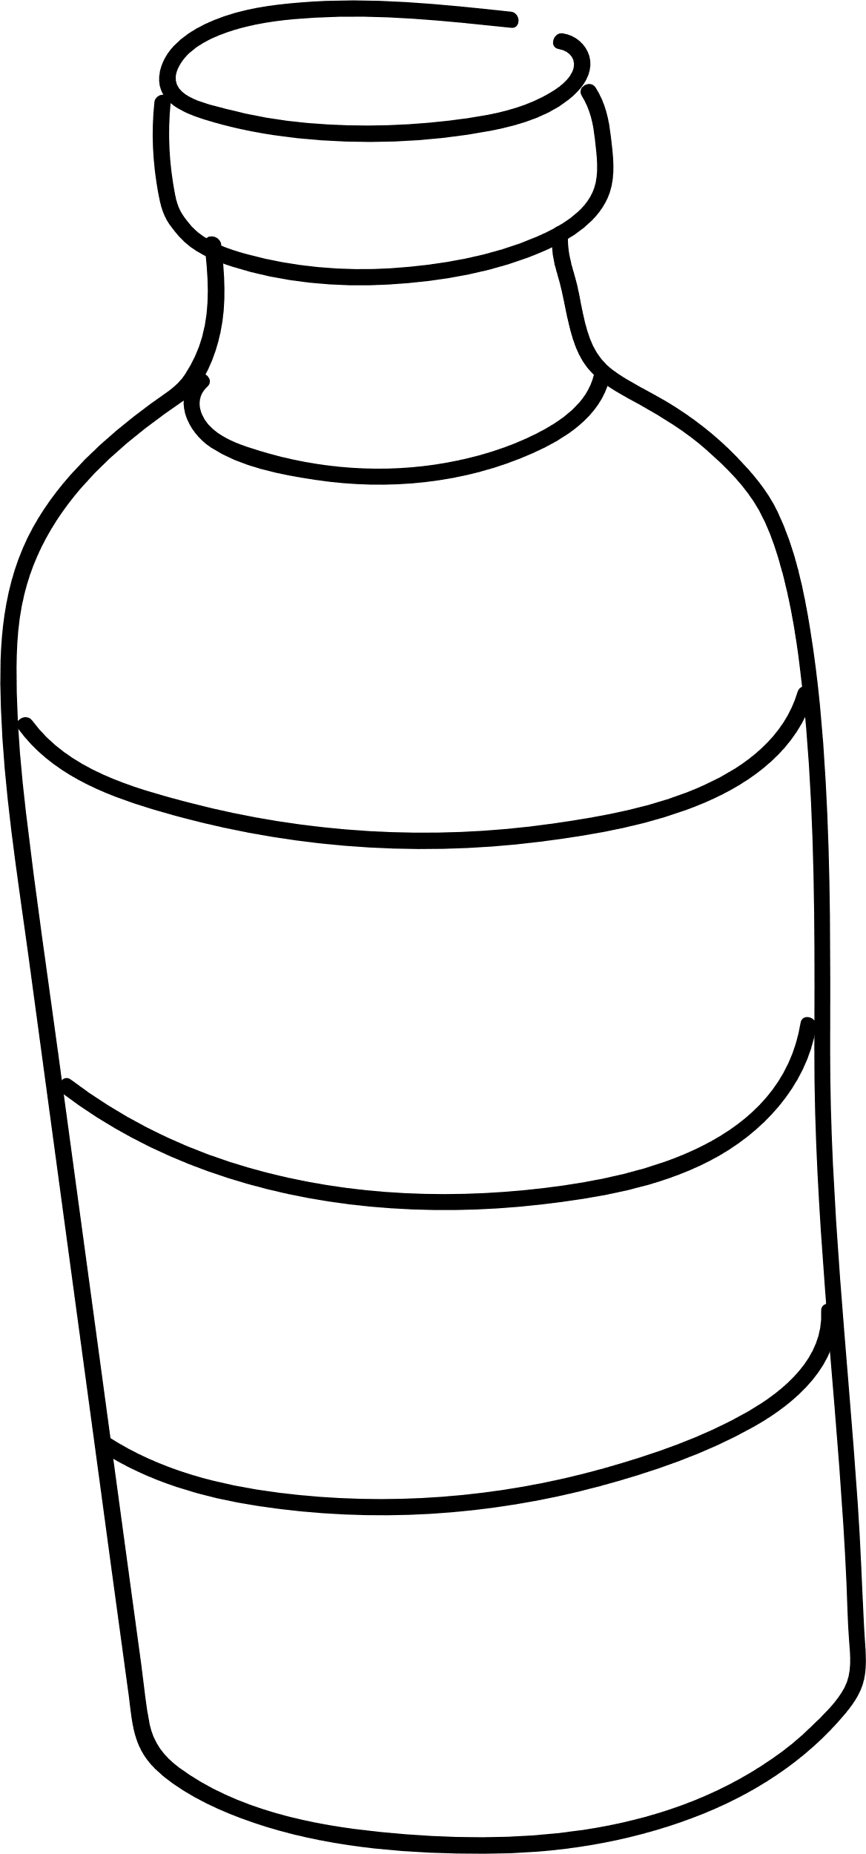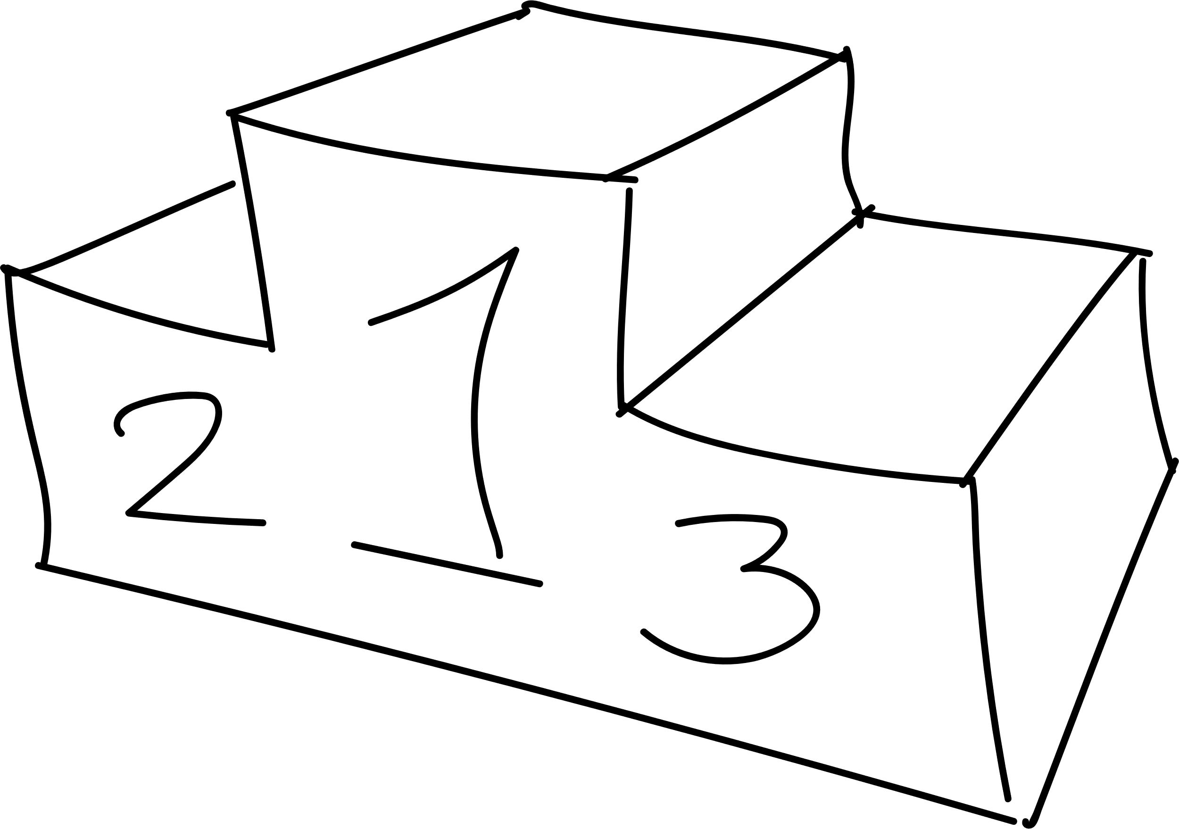

Sustainable C.L.O.CK

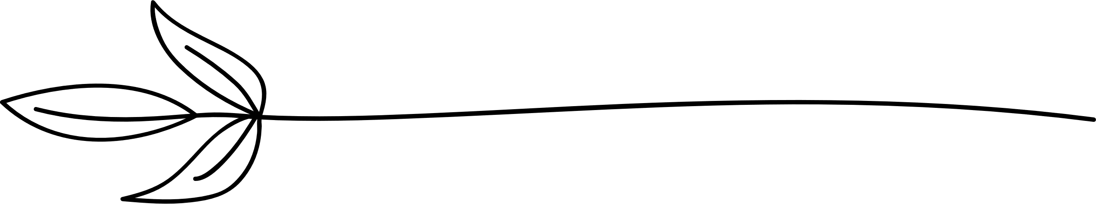

my food diary

Name___________________



# Breakfast



|  |  |  |  |  |  |  |  |  |  |  |
| --- | --- | --- | --- | --- | --- | --- | --- | --- | --- | --- |
|  | Monday |  |  |  | Tuesday |  |  |  | Wednesday |  |
|  |  |  |  |  |  |  |
|  | | |  |  | | |  |  | | |
|  | | |  | | |  |  |  |  |
|  | | |  | | |  |  | | |
|  |  |  |  | | |  |  | | |
|  |  |  |  |  |  |  |  |  |  |
|  | Thursday |  |  |  | Friday |  |  |  | Saturday |  |
|  |  |  |  |  |  |  |  |
|  | | |  |  | | |  |  | | |
|  | | |  |  | | |  |  | | |
|  | | |  |  |  |  |  |  | | |
|  | | |  |  |  |  |  |  |  |  |
|  |  |  |  |  |  |  |  |  |  |  |

|  |  |  |
| --- | --- | --- |
|  | Sunday |  |
|  |  |
|  | | |
|  | | |
|  | | |

# Mid-morning snack



|  |  |  |  |  |  |
| --- | --- | --- | --- | --- | --- |
|  | Mon |  | Tue |  | Wed |
|  |  |  |  |  |  |
|  |  |  |  |  |  |
|  |  |  |  |  |  |
|  |  |  |  |  |  |
|  |  |  |  |  |  |
|  |  |  |  |  |  |
|  | Thu |  | Fri |  | Notes |
|  |  |  |  |  |  |
|  |  |  |  |  |  |
|  |  |  |  |  |  |
|  |  |  |  |  |  |
|  |  |  |  |  |  |
|  |  |  |  |  |  |
|  | Sat |  | Sun |  |  |
|  |  |  |  |
|  |  |  |  |  |  |
|  |  |  |  |  |  |
|  |  |  |  |  |  |
|  |  |  |  |  |  |
|  |  |  |  |  |  |

# Packaging



## Tick each time you use

|  |  |  |  |
| --- | --- | --- | --- |
| PLASTIC |  | PAPER |  |
|  |  |
|  |  |
|  |  |
|  |  |
|  |  |
|  |  |
|  |  |
| GLASS |  | TIN |  |
|  |  |
|  |  |
|  |  |
|  |  |
|  |  |
|  |  |