TITLE: KNIGHT RIDER LEDS (CYLON EYE)

LEARNING SCENARIO
School: |  | Duration (minutes): | 40
Teacher: |  | Students  age: | 12 -13

Essential Question:

Topics:
- Arduino Programing Card and Block coding (Mblock)
Aims:
- They will use at least 4 Leds and code them by Mblock.
Outcomes:
- They will understand the basic electronic circuit.
- They will use digital pin and GND
- They will use LED, Resistor, breadboard, Jumper Cable
- They will code Arduino with Mblock.
- They will control digital pins with Mblock Code.
- They will use loop Mblock Code.
- They can adapt the circuit for the same task.
Work forms:

- Work in pairs

Methods:
Presentation and Project based Learning

ARTICULATION
Course of action (duration, minutes)
INTRODUCTION
- Remind the discussion at the last lesson. How can we turn on at least 4 LEDs although we have 3 GND? Is it Possible?
- Explain this:
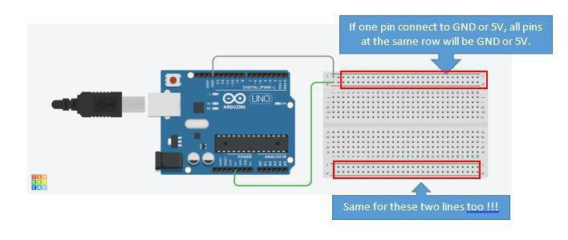
MAIN PART
- Let’s make Knight Rider Leds (Cylon Eye)
- Set up this circuit with Arduino and other equipment

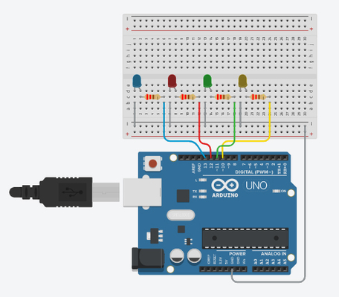
- Open Mblock and connect the Arduino
- Write this code:
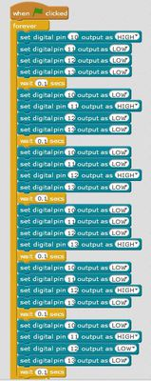

Video:
https://youtu.be/ldsH8nJqJY8

Scenarios for discussion
How can we set up this circuit with less jumper cable?

The other way of the circuit with less than 5 jumper Cable.
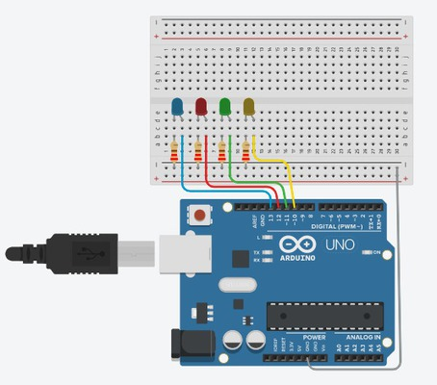
Video:
https://youtu.be/_QkEmbSb3Vw
CONCLUSION
The + line and the - line on the breadboard are connected horizontal, So if you connect the beginning of one of this line to GND all pins can be used as GND.

Methods | Work forms
presentation interview  talk demonstration  work on the text role playing  graphic work  interactive exercise /simulation on the computer | individual work  work in pairs  group work  frontal work

Material
- Arduino and USB connection Cable
- Computer
- 4 Leds
- BreadBoard
- 330 ohms Resistors
- Jumper Cables

Literature

PERSONAL OBSERVATIONS, COMMENTS AND NOTES

