TITLE: BLINKING LED

LEARNING SCENARIO
School: |  | Duration (minutes): | 40
Teacher: |  | Students  age: | 12 -13

Essential Question:

Topics:
- Arduino Programing Card and Block coding (Mblock)
Aims:
- They make blinking LED Project.
Outcomes:
- They will understand the basic electronic circuit.
- They will use digital pin and GND
- They will use LED, Resistor, breadboard, Jumper Cable
- They will control digital pin by Mblock Code
- They will use loop code.
Work forms:

- Work in pairs

Methods:
Presentation and Project based Learning

ARTICULATION
Course of action (duration, minutes)
INTRODUCTION
- Remind the digital pins.
Digital Pins: Digital pins on the Arduino are pins designed to be configured as inputs or outputs according to the needs of the user. Digital pins are either on or off. When ON they are in a HIGH voltage state of 5V and when OFF they are in a LOW voltage state of 0V.
In this lesson Digital pin will be use to control the led!
MAIN PART
- Set up this circuit with Arduino and other equipment.

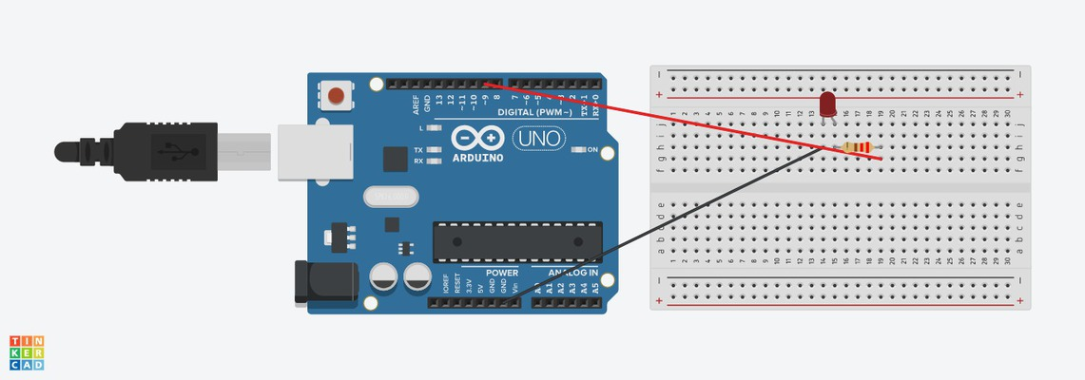

If you connect longest leg of LED to digital pin, You can control it. At this time we connect it 9th digital pin to control it.
TİP:
!!! If you want to check you circuit if it is correct, You can connect the longest leg of LED 5V. Because 5V always provide electrical current. But digital pin provide electrical current according to codes… So that you can control digital pin by coding, but not 5V!!!
- Open Mblock and connect the Arduino
- Write this code
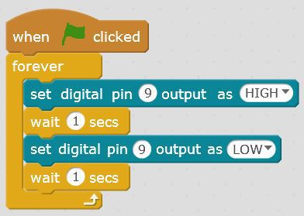

- Upload the code to Arduino
If it does not work check the circuit!

Video:
https://youtu.be/q5DYN8tZu-o

Discussion Question
There are just 3 GND pins on the Arduino. Does it mean that more than 3 led cannot be turned on?

CONCLUSION
We use the 9th digital pin to control LED. If it is high that mean is voltage state of 5V, it turns on. If it is low that mean is voltage state of 0V, it turns off.

Methods | Work forms
presentation interview  talk demonstration  work on the text role playing  graphic work  interactive exercise /simulation on the computer | individual work  work in pairs  group work  frontal work

Material
- Arduino and USB connection Cable
- Computer
- Led
- BreadBoard
- Resistor
- Jumper Cable

Literature

PERSONAL OBSERVATIONS, COMMENTS AND NOTES

