TITLE: Arduino

LEARNING SCENARIO
School: |  | Duration (minutes): | 40
Teacher: |  | Students  age: | 12 -13

Essential Question:

Topics:
- Arduino Programing Card and Block coding (Mblock)
Aims:
- They make the basic Led circuit by using 5V pin
Outcomes:
- They will understand the basic electronic circuit
- They will use 5V pin and GND
- They will use LED, Resistor, breadboard, Jumper Cable
Work forms:

- Work in pairs

Methods:
Presentation and Project based Learning

ARTICULATION
Course of action (duration, minutes)
INTRODUCTION
What are the elements of the basic Electronic circuit?
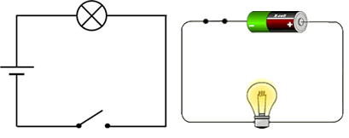
MAIN PART
Let’s set up this circuit with Arduino and other equipment.
- Introduce LED, Resistant, breadboard and Jumper cable
LED: LEDs are small, powerful lights that are used in many different applications.
Resistor: When building your Arduino projects, you use resistors to limit the amount of current going to certain components in the circuit, such as LEDs and integrated circuits. To calculate the resistance, you should use a modified version of Ohm’s Law.
Breadboard: The breadboard is the bread-and-butter of DIY electronics. Breadboards allow beginners to get acquainted with circuits without the need for soldering, and even seasoned tinkerers use breadboards as starting points for large-scale projects.

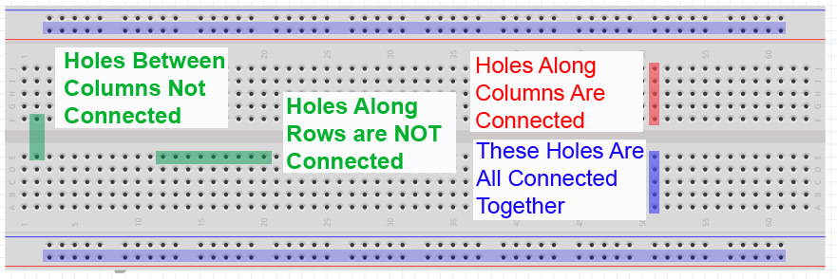

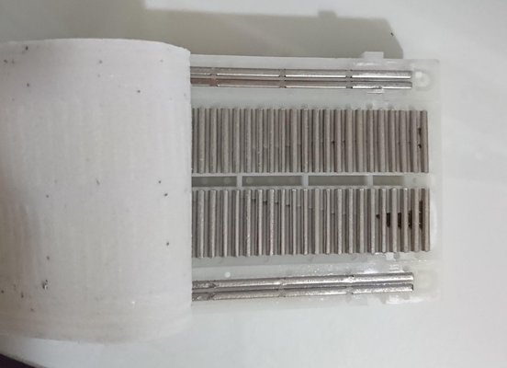

-Make this circuit
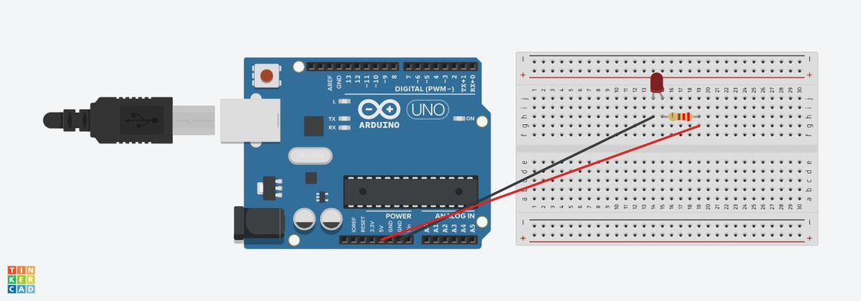

Video:
https://youtu.be/lglww2hl8jE

Topics for discussion
How can we control The LED?
Scenarios for discussion
Can we control this LED with 5V pin?
What should we do If we want to control this led (for example, turn on 1 minute, turn off 1 minute)?

CONCLUSION
We use the 5V pin for power supply, we cannot control it by coding. We have to use digital pins to control the leds or other elements of circuits by coding.

Methods | Work forms
presentation interview  talk demonstration  work on the text role playing  graphic work  interactive exercise /simulation on the computer | individual work  work in pairs  group work  frontal work

Material
- Arduino and USB connection Cable
- Computer
- Led
- BreadBoard
- Resistor
- Jumper Cable

Literature

PERSONAL OBSERVATIONS, COMMENTS AND NOTES

