TITLE: Servo Motor

LEARNING SCENARIO
School: |  | Duration (minutes): | 40
Teacher: |  | Students  age: | 12 -13

Essential Question:

Topics:
- Arduino Programing Card and Block coding (Mblock)
Aims:
- They will understand how to use Servo motors
Outcomes:
- They will code Arduino with Mblock.
- They will use servo motor
Work forms:

- Work in pairs

Methods:
Presentation and Project based Learning

ARTICULATION
Course of action (duration, minutes)
INTRODUCTION
Talk about the final project:
We will connect a servo motor to Arduino and code it with Mblock.
MAIN PART

- Let’s code a servo motor.
- Set up this circuit with Arduino and servo motor.
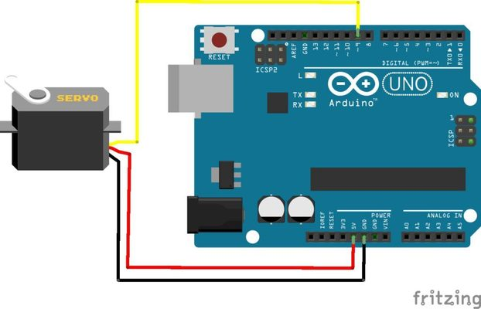

- Open Mblock and connect the Arduino
- Write this code:

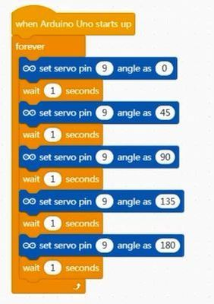

Video: https://youtu.be/Fy7cwyKUSGk

Scenarios for discussion

Where are servo motors used ?
CONCLUSION
We learnt how to connect the servo motor to Arduino.

Methods | Work forms
presentation interview  talk demonstration  work on the text role playing  graphic work  interactive exercise /simulation on the computer | individual work  work in pairs  group work  frontal work

Material
- Arduino and USB connection Cable
- Computer
- LCD Monitor with I2c module
- Ultra sonic Distance Sensor
- jumper Cables

Literature

PERSONAL OBSERVATIONS, COMMENTS AND NOTES

