TITLE: Distance meter

LEARNING SCENARIO
School: |  | Duration (minutes): | 40
Teacher: |  | Students  age: | 12 -13

Essential Question:

Topics:
- Arduino Programing Card and Block coding (Mblock)
Aims:
- They will understand the principle of basic tools.
Outcomes:
- They will code Arduino with Mblock.
- They will use LCD
- They will use Ultrasonic distance sensor
- They will write the data come from sensor on the LCD monitor
Work forms:

- Work in pairs

Methods:
Presentation and Project based Learning

ARTICULATION
Course of action (duration, minutes)
INTRODUCTION
Talk about the final project:
We will measure the the distance to other object with ultra-sonic distance sensor and the distance will be display on the LCD monitor.
MAIN PART

- Let’s make a Distance meter
- Set up this circuit with distance sensor and LCD monitor with I2C module
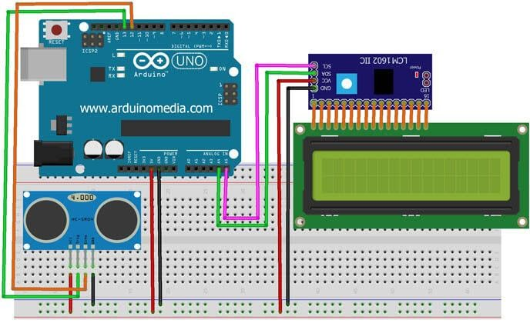
- Open Mblock and connect the Arduino
- Don't forget the extention of LCD monitor and HC – SR04 ultrasonic Distance Sensor.
- Write this code:

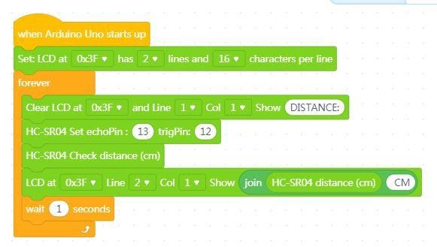

Video: https://youtu.be/f9v9jMb753w
CONCLUSION
We provided to display the data come from the sensor on LCD Monitor.

Methods | Work forms
presentation interview  talk demonstration  work on the text role playing  graphic work  interactive exercise /simulation on the computer | individual work  work in pairs  group work  frontal work

Material
- Arduino and USB connection Cable
- Computer
- LCD Monitor with I2c module
- Ultra sonic Distance Sensor
- jumper Cables

Literature

PERSONAL OBSERVATIONS, COMMENTS AND NOTES

