TITLE: LCD Monitorand Ic2 Module

LEARNING SCENARIO
School: |  | Duration (minutes): | 40
Teacher: |  | Students  age: | 12 -13

Essential Question:

Topics:
- Arduino Programing Card and Block coding (Mblock)
Aims:
- They will learnhow to use LCD monitor as display
Outcomes:
- They will code Arduino with Mblock.
- They will use LCD
Work forms:

- Work in pairs

Methods:
Presentation and Project based Learning

ARTICULATION
Course of action (duration, minutes)
INTRODUCTION
Talk about the final project:
We will write text via arduino and use LCD monitor to display this text
MAIN PART

- Give information about LCD Monitors and I2c Module
LCDs like these are very popular and broadly used in electronics projects as they are good for displaying information like sensors data from your project.
The 16x2 LCD has a total of 16 pins. As shown, eight of the pins are data lines (pins 7-14), two are for power and ground (pins 1 and 16), three are used to control the operation of LCD (pins 4-6), and one is used to adjust the LCD screen brightness (pin 3). The remaining two pins (15 and 16) power the backlight.
As seen in the Picture, If you use LCD with 16 pins, you have to make at least 12 connections. But IC2 module make it more easer.

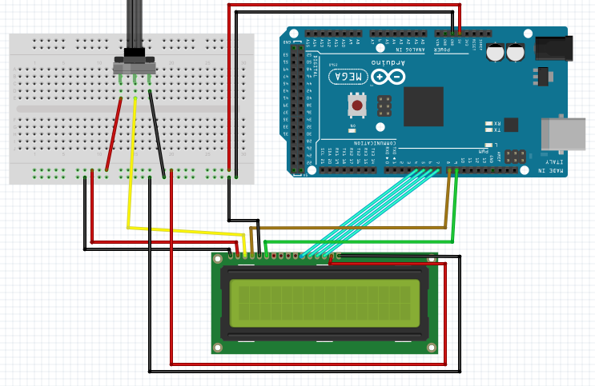
Wiring an I2C LCD is a lot easier than connecting a standard LCD. You only need to connect 4 pins instead of 12.
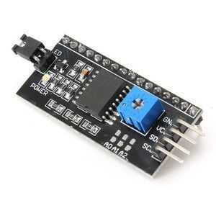
- Let’s make Park Sensor
- Set up this circuit with Arduino and LCD monitor with I2C module
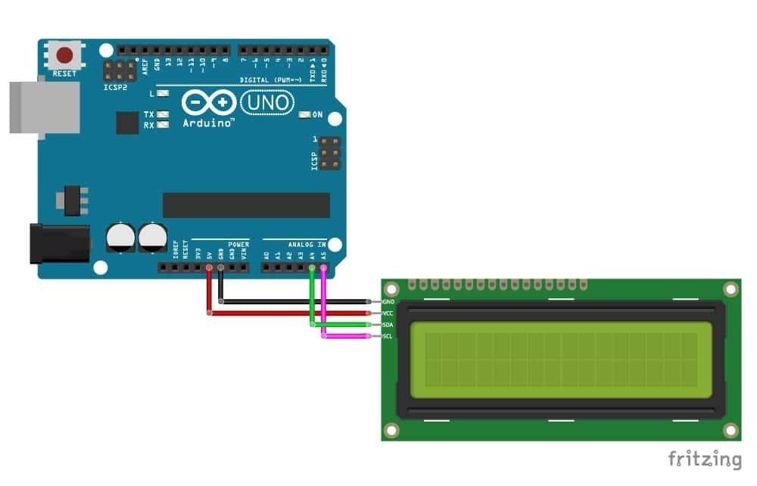
- Open Mblock and connect the Arduino
- Write this code:

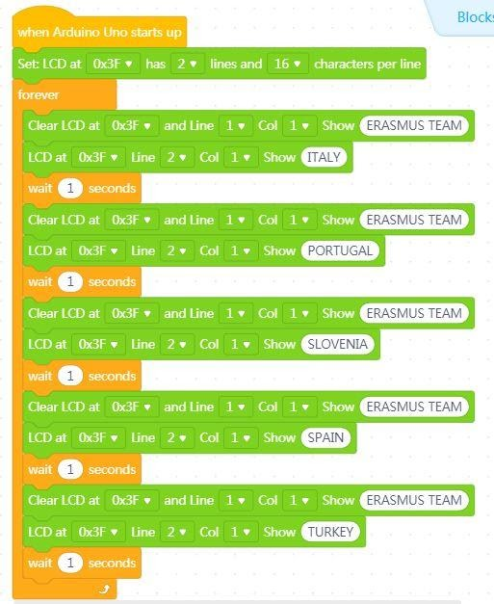

Video:
https://youtu.be/BvS7k-wlWaM

Scenarios for discussion
In which projects can we use LCD Monitors ?
CONCLUSION
We read the data come from analog pins and we used these data as conditions for another equipment’s working.

Methods | Work forms
presentation interview  talk demonstration  work on the text role playing  graphic work  interactive exercise /simulation on the computer | individual work  work in pairs  group work  frontal work

Material
- Arduino and USB connection Cable
- Computer
- LCD Monitor with I2c module
- jumper Cables

Literature

PERSONAL OBSERVATIONS, COMMENTS AND NOTES

