TITLE: PARK SENSOR WITH ULTRASONIC SENSOR &LEDs

LEARNING SCENARIO
School: |  | Duration (minutes): | 40
Teacher: |  | Students  age: | 12 -13

Essential Question:

Topics:
- Arduino Programing Card and Block coding (Mblock)
Aims:
- They will make a park sensor with LEDs
Outcomes:
- They will use sensors with Analog pins
- They will control Leds according to data come from sensor.
- They will code Arduino with Mblock.
- They will use conditional Code (IF)
- They will use loop Mblock Code.
- They will read data come from sensor with Mblock Code.
Work forms:

- Work in pairs

Methods:
Presentation and Project based Learning

ARTICULATION
Course of action (duration, minutes)
INTRODUCTION
Talk about the final project:
We will make a park sensor which is work according to distance from other object by using 3 LEDs. If the distance is over 30Cm all lights are turning off. If the distance is between 30cm and 20cm, one led will turn on. If the distance is between 20 cm and 10cm, two Leds will turn on. If the distance less than 10 cm, all leds will turn on.
MAIN PART

- Give information about Ultrra sonic Distance Sensor
Ultrasonic distance sensor measures distance by sending ultrasound (40 kHz) and this ultrasound will bounce off the obstacle and return to the sensor. Distance is measured by time it takes the ultrasound to travel from the sensor and back to the sensor.
- Let’s make Park Sensor
- Set up this circuit with Arduino and other equipment
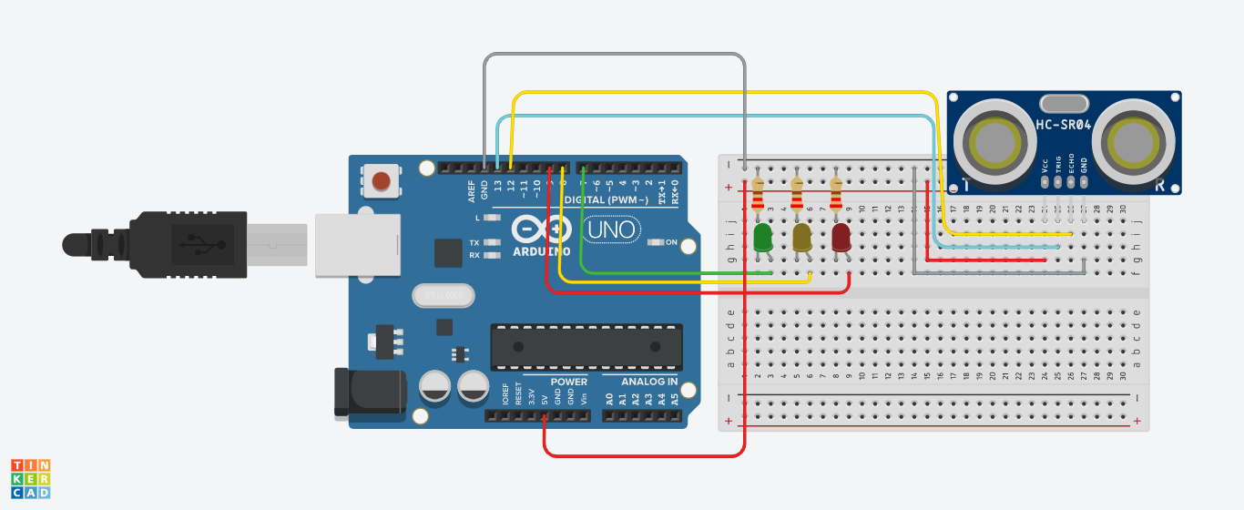

- Open Mblock and connect the Arduino
- Write this code:

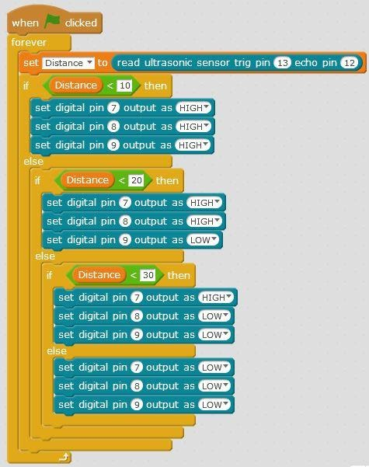

Video:
https://youtu.be/1gBoByl8wps

Scenarios for discussion
Can we code it for the same task by the different way?
CONCLUSION
We read the data come from analog pins and we used these data as conditions for another equipment’s working.

Methods | Work forms
presentation interview  talk demonstration  work on the text role playing  graphic work  interactive exercise /simulation on the computer | individual work  work in pairs  group work  frontal work

Material
- Arduino and USB connection Cable
- Computer
- 3 leds
- Ultrasonic Distance Sensor
- BreadBoard
- 3 330 ohms Resistors
- jumper Cables

Literature

PERSONAL OBSERVATIONS, COMMENTS AND NOTES

