TITLE: Arduino

LEARNING SCENARIO
School: |  | Duration (minutes): | 40
Teacher: |  | Students  age: | 12 -13

Essential Question:

Topics:
- Arduino Programing Card and Block coding (Mblock)
Aims:
- They understand how to use Arduino.
Outcomes:
- They will recognise the Arduino programing card
- They will recognise the digital pins, 5V pins and GND Pins
- They will connect Arduino to computer by using USB plug Cable
- They will explain that Arduino is open Source
- If they use Clone Arduino, they will know that they need to upload the driver.
- They will connect with MBlock

Work forms:

- Work in pairs

Methods:
- Presentation

ARTICULATION
Course of action (duration, minutes)
INTRODUCTION
The history and story of development of Arduino is mentioned briefly…
“It was in the year 2005 that the first ever Arduino board was born in the classrooms of the Interactive Design Institute in Ivrea, Italy. Well, if you are not very familiar with the term, an Arduino is an Open Source microcontroller based development board that has opened the doors of electronics to a number of designers and creative engineers.
It was in the Interactive Design Institute that a hardware thesis was contributed for a wiring design by a Colombian student named Hernando Barragan. The title of the thesis was “Arduino–La rivoluzione dell’open hardware” (“Arduino – The Revolution of Open Hardware”). Yes, it sounded a little different from the usual thesis but none would have imagined that it would carve a niche in the field of electronics.”
Open Source Coding term is explained by emphasizing that Arduino is Open Source.
Open-source software (OSS) is computer software that is released under a license in which the copyright holder grants users the rights to use, study, change, and distribute the software and its source code to anyone and for any purpose.
MAIN PART

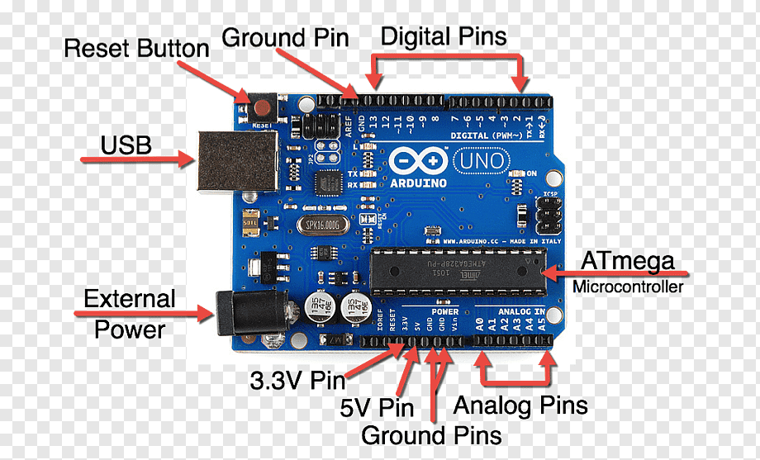
Let’s start with pins which we will use at the beginning:
Digital pins: Digital pins on the Arduino are pins designed to be configured as inputs or outputs according to the needs of the user. Digital pins are either on or off. When ON they are in a HIGH voltage state of 5V and when OFF they are in a LOW voltage state of 0V.
5V Pin: The regulated power supply used to power the microcontroller and other components on the board.
GND Pin: Ground pins.
Analog pins: The ATmega controllers used for the Arduino contain an onboard 6 channel (8 channels on the Mini and Nano, 16 on the Mega) analog-to-digital (A/D) converter. The converter has 10 bit resolution, returning integers from 0 to 1023. While the main function of the analog pins for most Arduino users is to read analog sensors, the analog pins also have all the functionality of general purpose input/output (GPIO) pins (the same as digital pins 0 - 13).

Let’s connect to with Mblock

- Connect Arduino Uno to computer by using USB Cable (Blue one)
- Open Mblock (You can use online version too.)
- Add Arduino as device
- Click Connect button.
- Chose “show all connectable devices
- Choose connection Port
You can watch : https://www.youtube.com/watch?v=8q6-1Iagdrg

Topics for discussion
Why is Arduino so common?

Scenarios for discussion
Why is Arduino so common? Is asked to classroom.
Is it cheap or expensive?
Why is it cheaper?
CONCLUSION
Because of being open source, Clone Arduinos are produced. If you use clone Arduino, remind to upload the driver for it at the first usage.

Methods | Work forms
presentation interview  talk demonstration  work on the text role playing  graphic work  interactive exercise /simulation on the computer | individual work  work in pairs  group work  frontal work

Material
- Arduino and USB connection Cable
- Computer
- Mblock SoftWare

Literature

- https://www.circuitstoday.com/story-and-history-of-development-of-arduino
- https://en.wikipedia.org/wiki/Open-source_software
- https://www.youtube.com/watch?v=D4D1WhA_mi8
- https://www.youtube.com/watch?v=8q6-1Iagdrg
- https://www.youtube.com/watch?v=UoBUXOOdLXY
- https://electropeak.com/learn/how-to-install-ch340-driver/

PERSONAL OBSERVATIONS, COMMENTS AND NOTES
Students will understand the tasks of pins on Arduino by making Arduino projects.

