Ecosystem card: School Park
Weather conditions during the survey  (eg . the pressure, cloudiness, humidity, temperture) | Sunny: 30°C  lack of cloud cover  Atmospheric Pressure: 1015hPa  lack of rainfall
Characteristics of biotope  (eg . water relations, soil profile, soil type) | Pond: ph = 7.7  PO₄ = 0.41 mg / l  Brook Wirenka: ph = 8.2  PO₄ = 0.25  Water fertile - eutrophic  Closed tank favors the meeting of the organic compounds that water flows more easily cleans and varies with the test chemical composition.
Characteristics biocenosis  (eg . plants, animals, fungi, endangered organisms; use of the Latin language and images / diagrams) | Attachment 1
Characteristics of dependence | The description in the following table
Conclusions | The description in the following table

Ecosystem card: Wielkopolski National Park
Weather conditions during the survey  (eg . the pressure, cloudiness, humidity, temperture) | Temperature 10°C (morning) - 13ºC  partly cloudy  Gentle wind  Atmospheric Pressure: 1027 hPa  lack of rainfall
Characteristics of biotope  (eg . water relations, soil profile, soil type) | Soil pH = 6  Lake Jarosławieckie:  The content of PO₄ = 00  NH₄ content = 00  NO₃ content = 00
Characteristics biocenosis  (eg . plants, animals, fungi, endangered organisms; use of the Latin language and images / diagrams) | Attachment 1
Characteristics of dependence | - We saw traces depending on food (leftovers Anguis gragilis) - predation. We observed traces of beavers' activity, as well as herbivores. These relations will be classified according to food (predation and herbivory).  - We gave examples of food chains and relationships occurring in the forest.  - We talked and watched the competition of plants in access to water and light (young tree vs. mature). We noted the relationship between plants in different floors of the forest.  - We discussed the changes in the forest ecosystem, depending on the time of year (the study took an interesting time: late summer and early autumn).  - We saw migrations of animals: deer tracks and trails so. Indian summer - the movement of young spiders on their spider threads in order to populate a new area, as well as hiking migratory birds flying from the Polish winter.  - We talked and watched symbiosis - positive coexistence of fungi and trees called mycorrhiza.  - We talked and watched the competition between different species of animals in access to food or water.  - We discussed the role of intraspecific competition in maintaining the health of the population.  - We talked and watched the example of parasitism hubs and trees, mistletoe and trees, as well as ticks.  - We discussed the role of dead wood in the forest: water relations, place of growth and insect life, a breeding ground zero and birds, place the development of fungi and plants, fertilization of the soil.  - On the occasion of observation of the seed and the tree Fagus sylvatica we discussed the importance of nature for years Fagus seed and changes in the ecosystem due to release the seeds for this species of tree.
Conclusions | - A forest is a complex ecosystem in which there are numerous depending on nature. Both those classified as friendly and unfriendly.  - The diversity of organisms of the National Park is high.  - Abiotic environment of the National Park has little traces of impurities (the study of the waters of Lake Jarosławieckie).  - The organisms feeding on dead organic matter fulfill a very important role in ecosystems.  - The role of dead wood in the forest is very important to preserve natural diversity, and determines the quality abiotic environment.  - Environment Park school environment is anthropogenic, even though it has a large variety of species of plants and animals (many amphibians, birds, and mammals: foxes, roe deer, wild boar).  - The water in the tanks is TVE traces of human existence, it is phosphorous and ammonia.  - we met various test methods of the natural environment: the study of water and soil, to record the voices of birds, GPS, photos taken by special equipment at night and others.

Attachment 1 – Ecosystem card
Plants, mushrooms and animals

Rośliny i grzyby naszej okolicy
Plants and mushrooms in our area
Szkolny Park & Wielkopolski Park Narodowy
School Park & Wielkopolski National Park

Nazwa gatunkowa  Wiąz Pospolity  -  Ulmus minor | 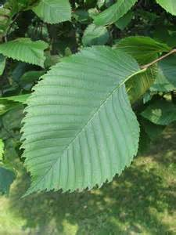
Lipa Drobnolistna  -  Tilia cordafa | 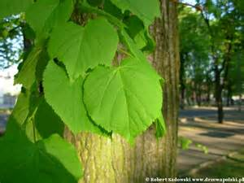
Modrzew Europejski  -  Larix decidua | 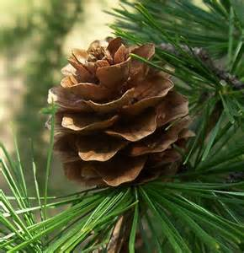
Jodła Pospolita  -  Abies alba | 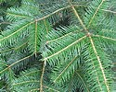
Świerk Pospolity  -  Picea abies | 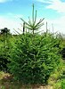
Pokrzywa Zwyczajna  -  Ultrica dioica | 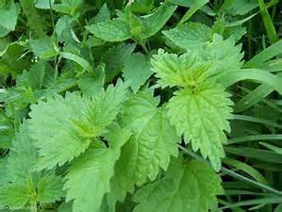
Jasnota Biała  -  Lamium album | 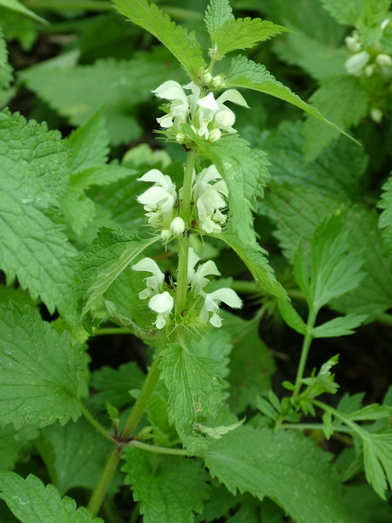
Jałowiec  Pospolity  -  Juniperus  communis | 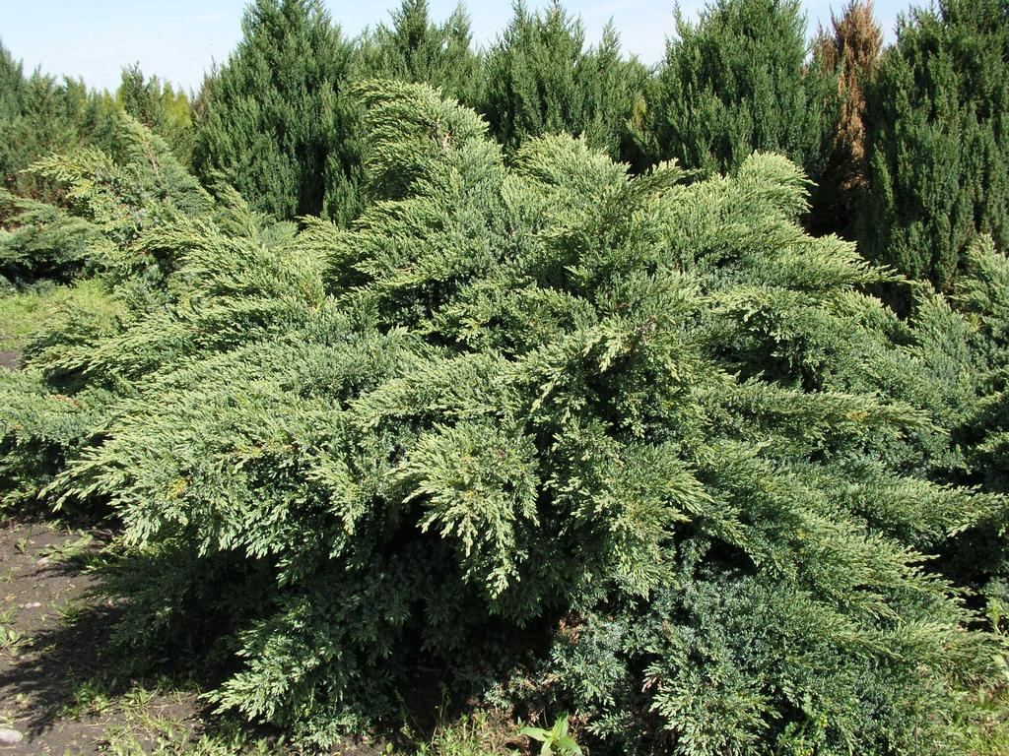

Mech płonnik  -  Polyfrichum Hedw. | 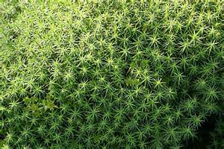
Rzęsa Wodna  -  Lemma  Minor | 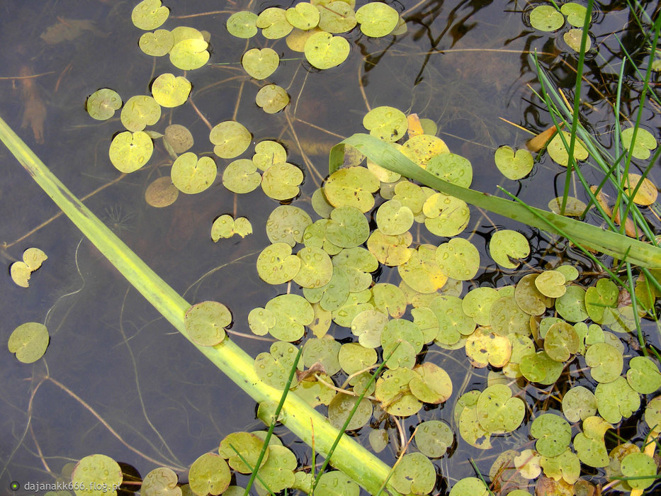
Platan Klonolistny  -  Platanus  acerifolia | 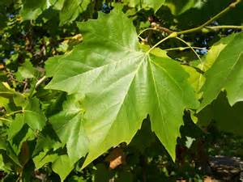
Dąb Szypułkowy  -  Qertus robur | 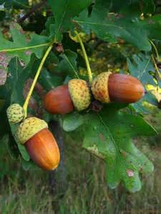
Dąb Bezszypułkowy  -  Quercus patreaa | 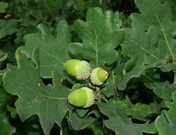
Grochodrzew  Zwyczajny  -  Robinia pseudo Akacja | 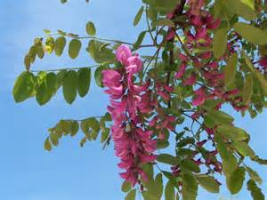
Buk Zwyczajny  -  Fagus sylvatica | 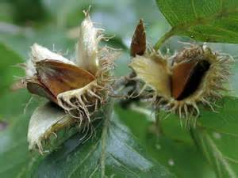

Jesion  Wynosły  -  Fraxinus excelsior | 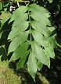

Klon Zwyczajny  -  Acer platanoides | 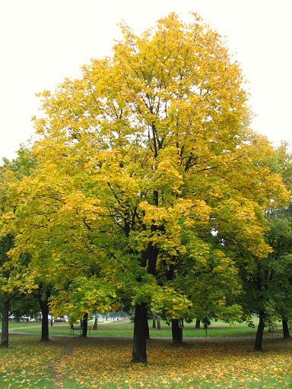
Paproć  zwyczajna  -  Polypodium  vulgare | 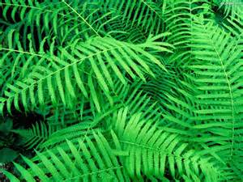
Babka lancetowata  -  Plantago  lanceolata | 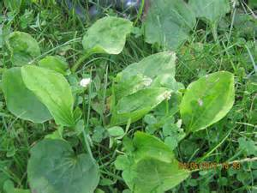
Mniszek lekarski  -  Taraxacum officinale | 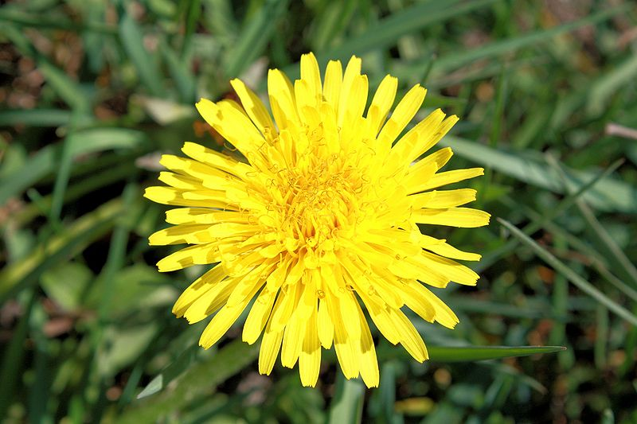

Grążel  -  Nuphar lufea | 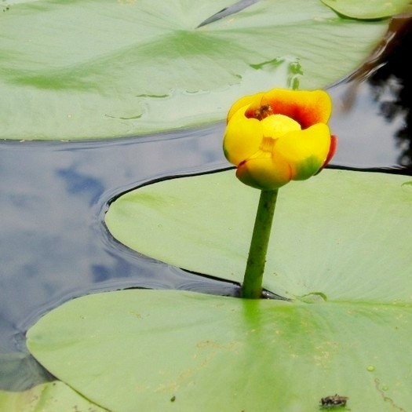
Pałka szerokolistna  -  Typcha  latifolia | 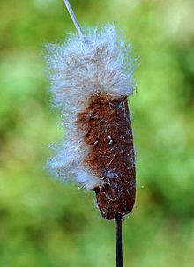

Czeremcha  amerykańska  -  Prunus  serotina | 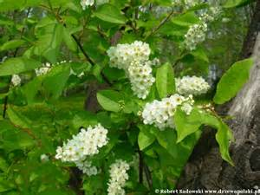
Borowik  szlachetny  -  Boletus  edulis | 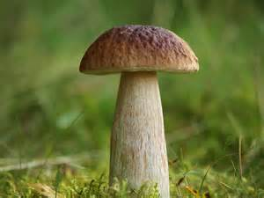
Hubiak  pospolity  -  Fomes  fomentarius | 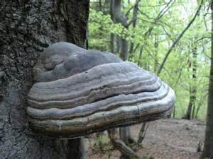
Muchomor  Czerwony  -  Amanita  muscaria | 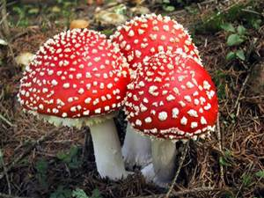
Pieprznik  Jadalny  -  Cantherelus  cibarius | 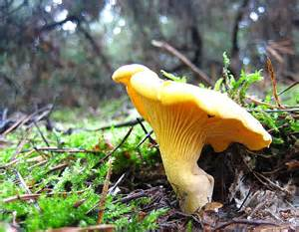
Podgrzybek  Brunatny  -  Boletus  badius | 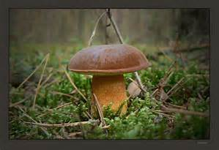
Sosna  Zwyczajna  -  Pinus  sylvestris | 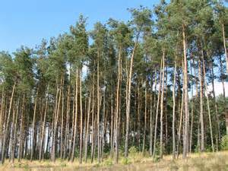

By Kacper, Szymon, Eliasz

Zwierzęta naszej okolicy
Animals of our area
Szkolny Park & Wielkopolski Park Narodowy
School Park & Wielkopolski National Park
Wiewiórka ruda  Sciurus vulgaris | 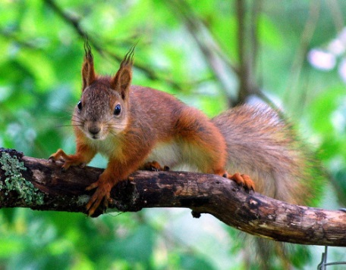
Dzik euroazjatycki  Sus scrofa | 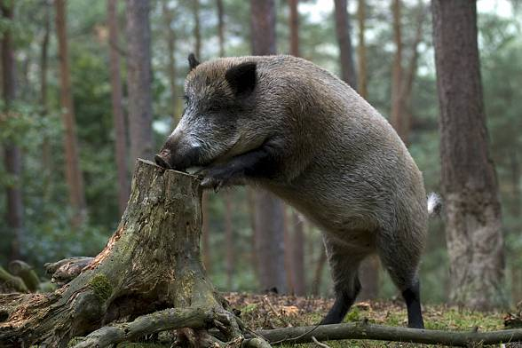
Myszołów  Buteo buteo | 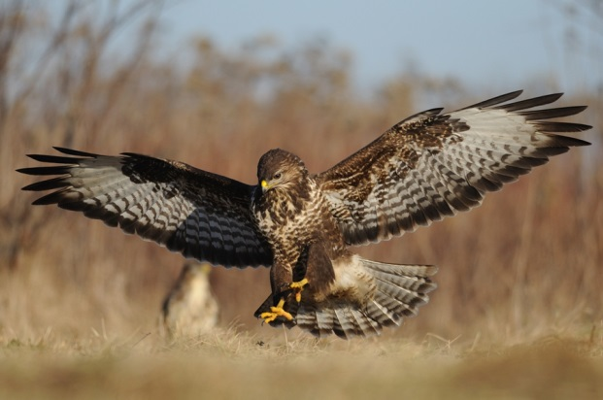
Kaczka krzyżówka  Anas platyrhynchos | 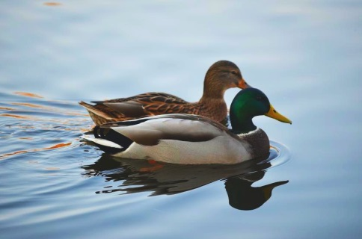
Fruczek gołąbek Macroglossum stellatarum | 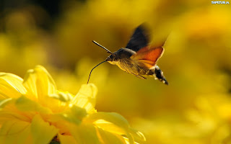
Biegacz gładki  Carabus glabratus | 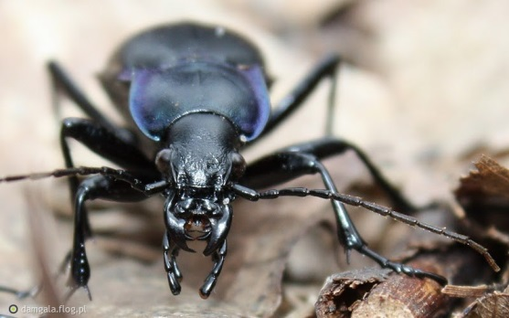
Trzpiennik olbrzym  Urocerus gigas | 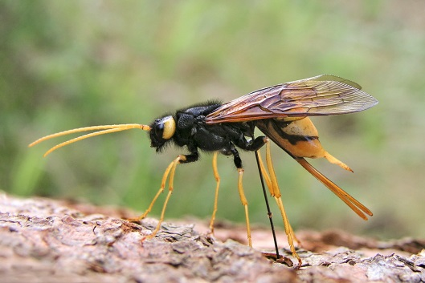
Sarna leśna | 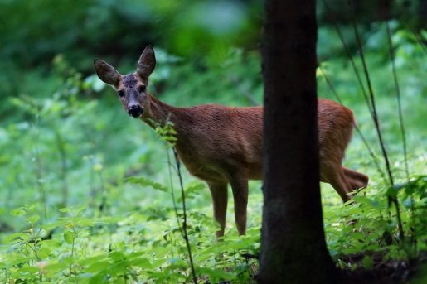
Kowal bezskrzydły  Pyrrhocoris apterus | 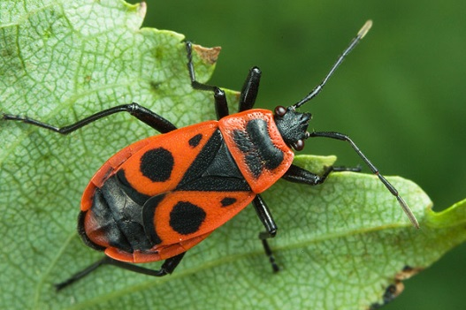
Ropucha zielona  Bufo riridis | 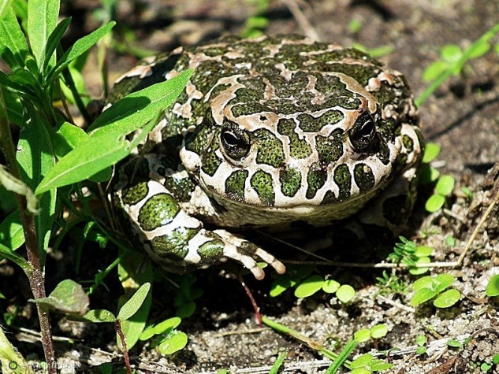
Padalec  Anguis fragilis | 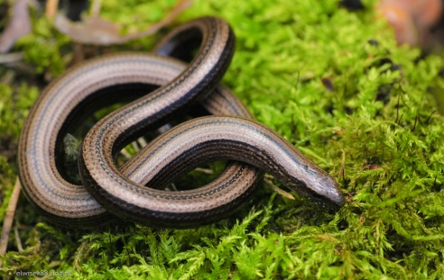
Ślimak winniczek  Helix pomateje | 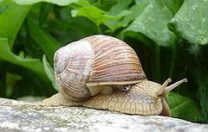
Żaba trawna  Rana temporiane | 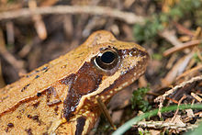
Jaszczurka zwinka  Lacerteofilis | 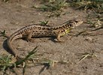
Gołąb grzywacz  Columba palumblus | 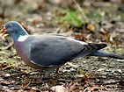
Dzięcioł czarny  Dryocopus martius | 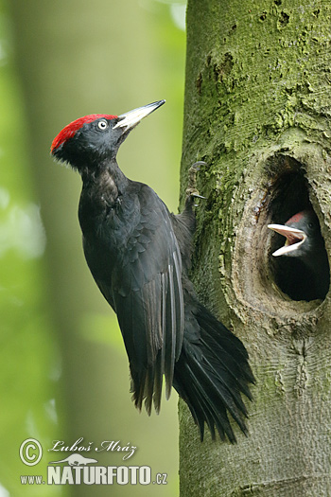
Nornica ruda  Modes glariolus | 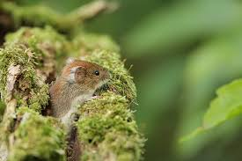
Rudzik  Aglais io | 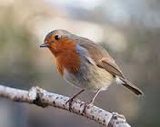
Perłowiec malinowiec  Argunnis paphia | 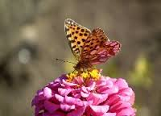
Rusałka admirał Vanessa atalanta | 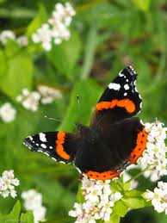
Zaskroniec zwyczajny  Natrix natrix | 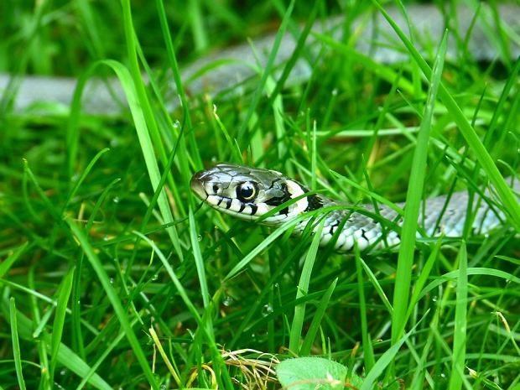
Harmonia axsyridis | 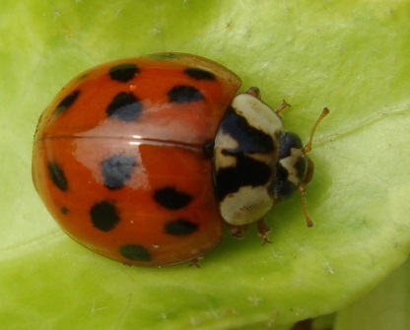
Kormoran zwyczajny  Phalacrocorax Carbo | 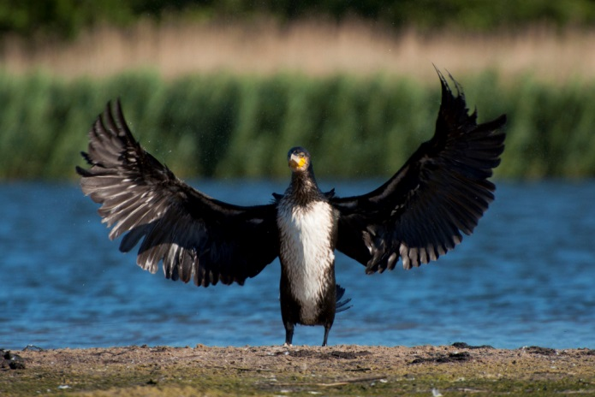

Kos zwyczajny  TURDUS MERULA | 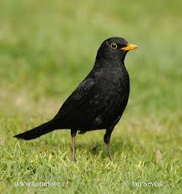
Borsuk europejski  Meles meles | 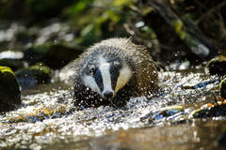
Mrówka rudnica  Formica rufa | 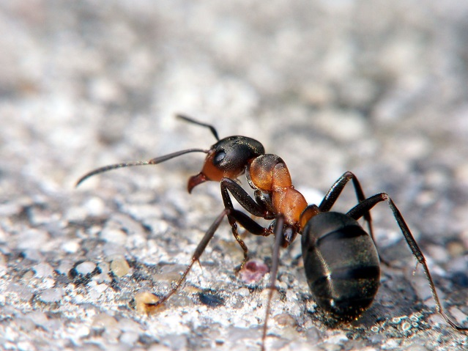
Nocek duży  Myotis myotis | 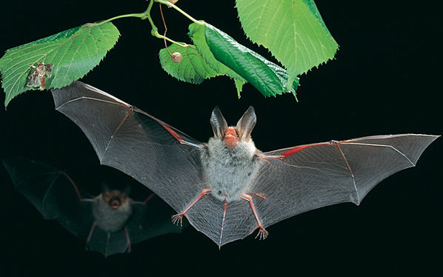
made by Tosia, Madzia, Lidia

TYGRZYK PASKOWANY  (ARGIOPE BRUENNICHI) | 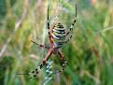
DZIĘCIOŁ DUŻY  (DENDROCOPOS MAJOR) | 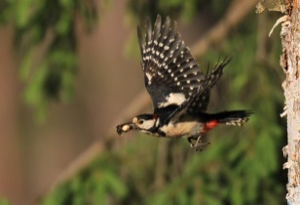
ŻUK GNOJARZ  (GEOTRUPES STERCORIUS) | 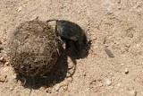
FRUCZEK GOŁĄBEK  (Macroglossum stellatarum) | 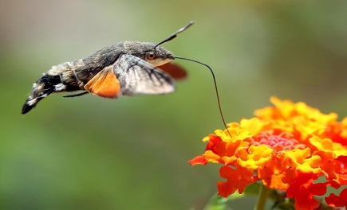
MYSZOŁÓW  (Buteo) | 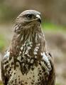
ZIELONA ĆMA | 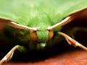
KRET | 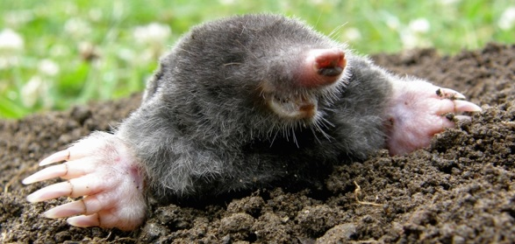
MYSZ  (Mus) | 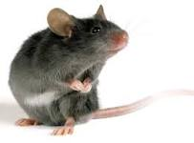
ROPUCHA ZIELONA  (BUFO VIRIDIS) | 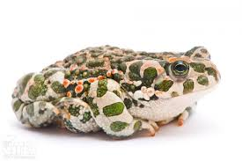
PADALEC  (ANGUIS FRAGILIS) | 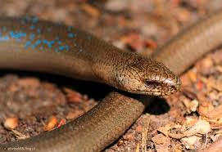
ŚLIMAK WINNICZEK  (HELIX POMATIA) | 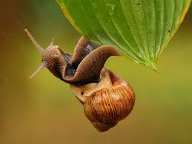
ŻABA TRAWNA  (RANA TEMPORARIA) | 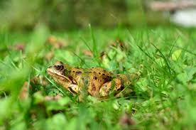
JASZCZURKA ZWINKA  (LACERTA AGILIS) | 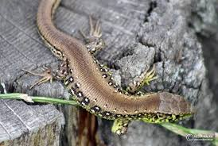
GOŁĄB GRZYWACZ  (COLUMBA PALUMBUS) | 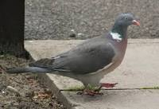
BOGATKA ZWYCZAJNA  (PARUS MAJOR) | 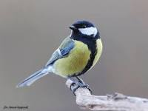
DZIĘCIOŁ CZARNY  (DRYOCOPIUS MARTIUS) | 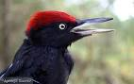
RUSAŁKA PAWIK  (AGLAIS IO) | 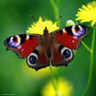
DOSTOJKA MALINOWIEC  (ARGYNNIS PAPHIA) | 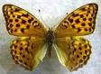
RUSAŁKA ADMIRAŁ  (VANESSA ATALANTA) | 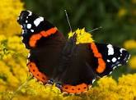
NORNICA RUDA  (MYODES GLAREOLUS) | 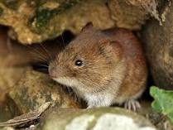
PAJĄK KRZYRZAK  (ARANEUS BIADENAUS) | 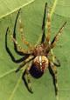
ZASKRONIEC ZWYCZAJNY  (NATRIX NATRIX) | 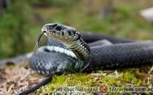
DZIK EOROAZIATYCKI  (SUS SCROFA) | 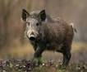
MRÓWKA RUDNICA  (FORMICA RUFA) | 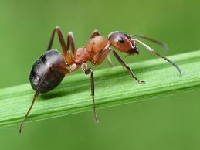
KOS ZWYCZAJNY  (TURDUS MERULA) | 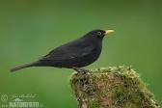
KORMORAN ZWYCZAJNY  (PHALACROCORAX CARBO) | 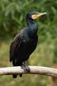
BORSUK EOROPEJSKI  (MELES MELES) | 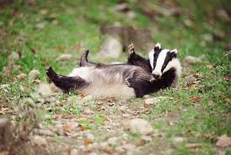
NOCEK DUŻY  (MYOTIS MYOTIS) | 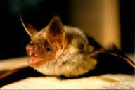
made by Janek, Stasiu, Oliwier, Jakub, Bartosz

