Justin Bieber: Mistletoe, Christmas vocabulary worksheet

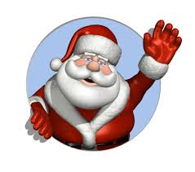 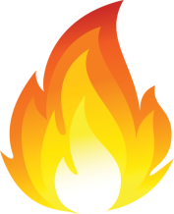 

_________________ _________________ _____________________

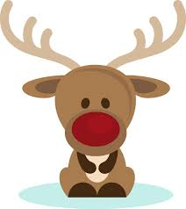 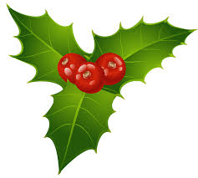 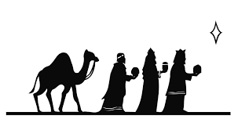

____________________ __________________ _____________________

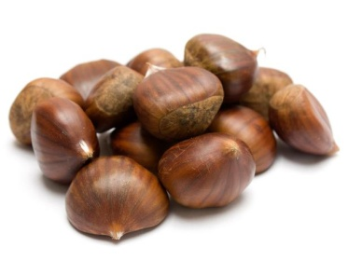 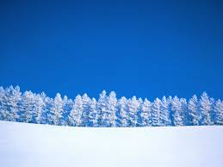 

__________________________ _______________________ ____________

Match the words and pictures.

stars, mistletoe, chestnuts, Santa, winter snow, reindeer, lights, wise men, fire