TURKEY PROMOTİON (ISTANBUL)

ISTANBUL

İstanbul is very important place in the world. Istanbul became the biggest and the most crowded city of Europe.Because, ıts location between Asia and Europe, the city always had a great geopolitical importance.the city population is estimate 12 to15 millions.
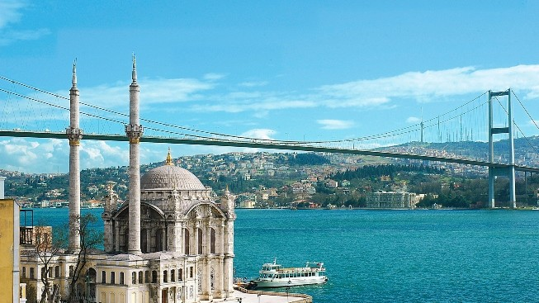

3
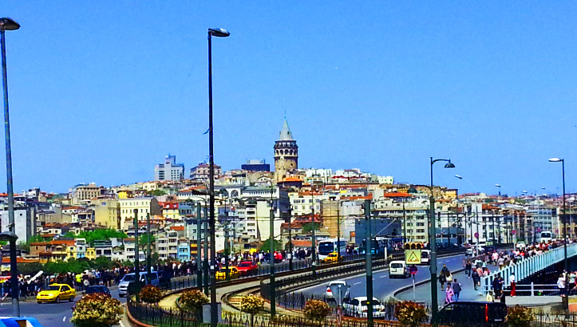
Around 2 millions tourists visit İstanbul every year.They are see the historical and natural beauties of the city. The city has a lots of historical mosque,church and museums of Turkey.
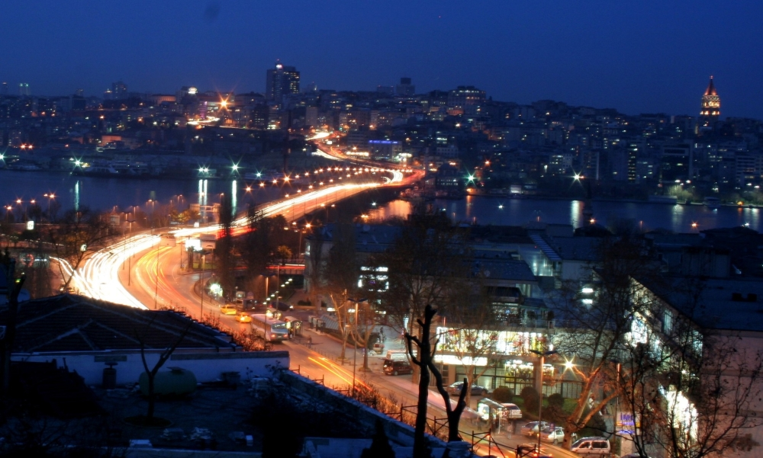
4
THE TAKSIM SQUARE
The large square at the end of the Istıklal street is the Taksim square, which is one of the most active centers of İstanbul.The square is the most important for Istanbul.There are a lot of different counturies people.There are a lot of big department store this place is really beatiful.
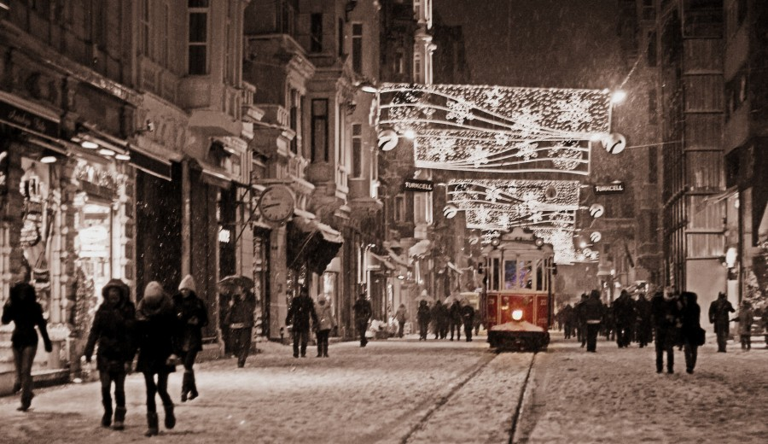

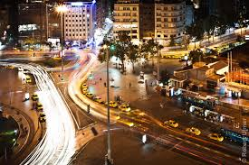
5

THE FATİH SULTAN MEHMET BRIDGE

The Fatih Sultan Mehmet Bridge was built between 1985 and 1988 the opening date was at the save time the 535th anniversary of the Otoman conquest of the city.

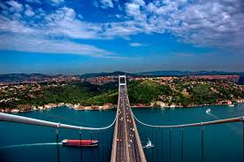

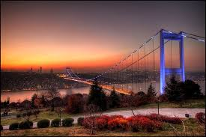

6
THE SÜLEYMANIYE MOSQUE
It was built by Architect Sinan, the most famous architect at Ottoman history between 1550-1557 Süleymaniye Mosque, according to the construction reports of those days,5.723 workers (of these 1.713 are Moslems, 3.523 Christians ) completed the construction in 2.7 million working days.The cost of the mosque is $60 millions today.
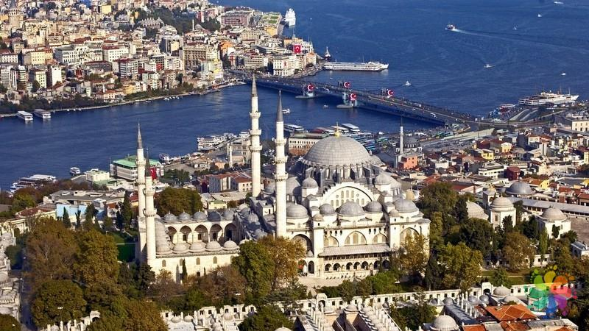

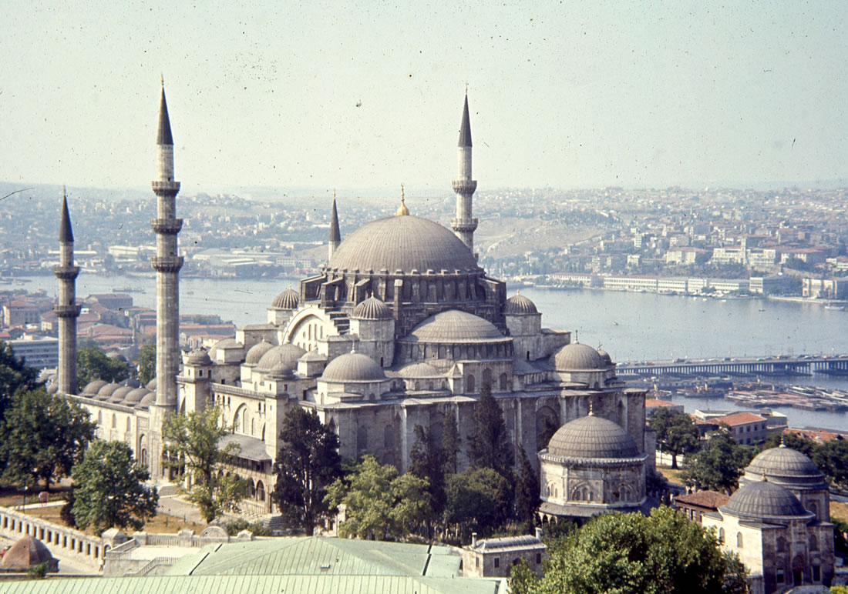
7
THE LEANDROS TOWER

The leandros Tower covers on area of 1250 m2 and was built 200 metres from the Usküdar beach.It has got a intelligent history.
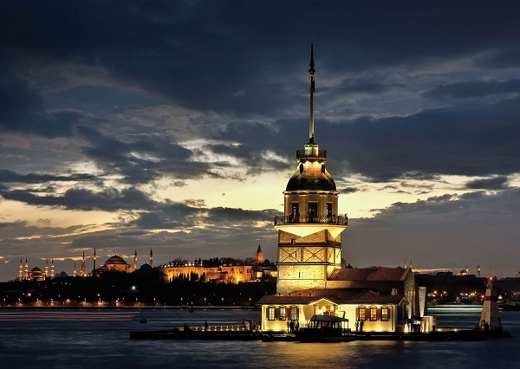

One day a witch has got apples for the girl and gave her a poisana us apple, she did after eating it.That is why the tower is called the Leandros Tower.

8

THE GALATA TOWER
This tower at the slopes of Galata is visible every where in the city, and is 61 m. tall.The tower is at the hill which over looks both to the Bospherus and the Golden Horn and the sea of Marmara.

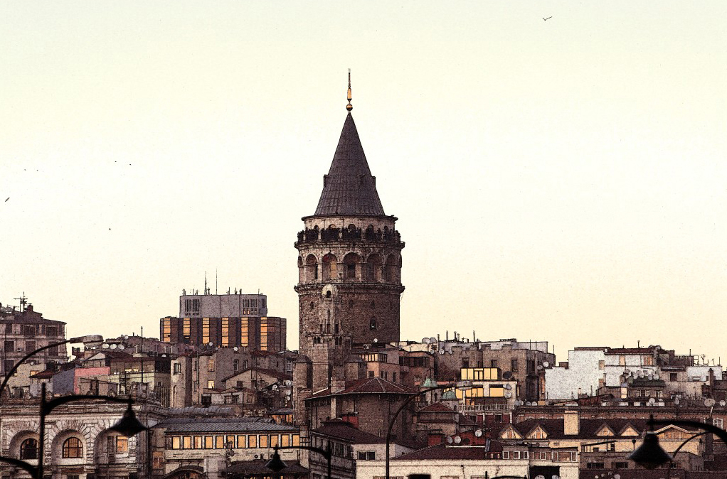

9

One day,an scientist named Hazerfen Ahmet Çelebi jumped down the tower and flew to the opposite side of the Bosphorus strait by using the wings which he had invented ( 17th century )
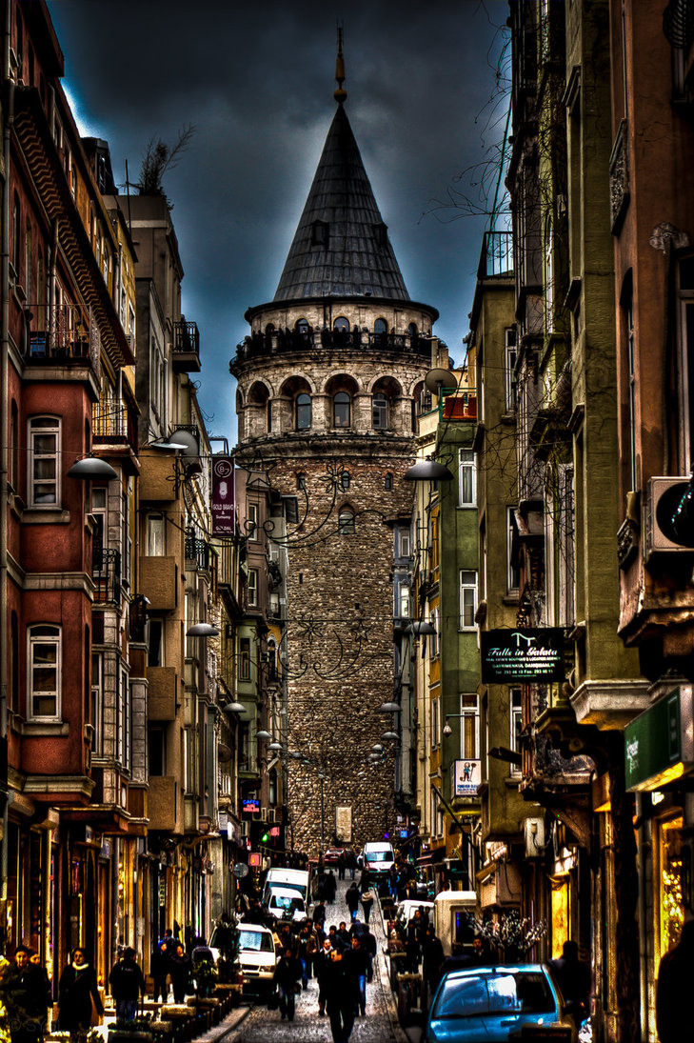
10
THE DOLMABAHÇE PALACE MUSEUM
The Dolmabahçe Palace Museum was built between 1611-1614.It ıs that 14 tens of gold and 40 tons of silver were used for the decoration of the palace.The furniture was bought from Paris, the vases from Hereke and Lyan,the crytal materials from Bccarant and the the can dlesticks from England with special order.Almost all of 131 large and 99smal hand-made carpets are silk carpets, and they were woven in the royal workshops in Hereke.The total area covered by the carpets is 4.500 square meters.The total area at the palace is 250.000 square meters.

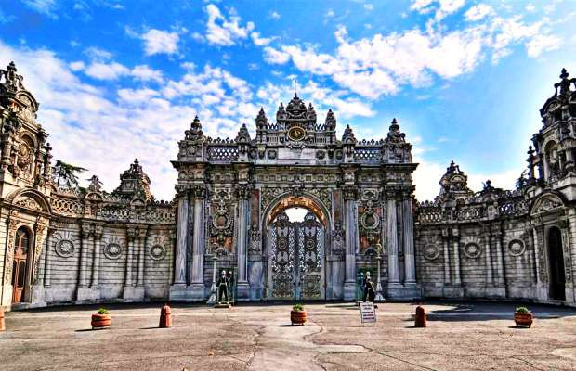

11
There are 12 gates.There are 285 rooms, 43 holls, 6 balconies, 6 hamams and 1427 windows.In the deconation, 156 clocks, 280 vases and 58 candle sticks.By the way, the carpet of 124 m2 is the second largest hand-made Hereke carpet in Turkey.

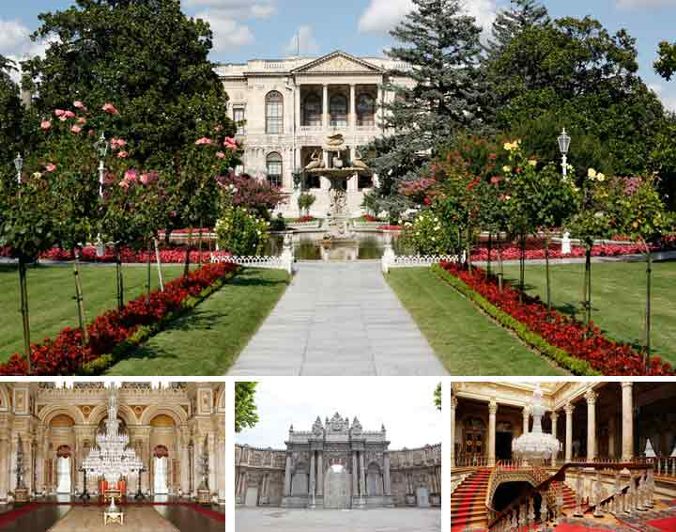

12

THE FORTRESS
It was constructed with the order of Yıldırım Beyazıd in 1393, during one of the sicges of İstanbul.It is opposite to the Rumeli Hisarı.In the previous period there was a Christian Church at the same place. Its original name was Güzelce Hisar.

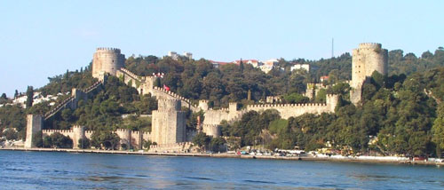

13

There are a lots of pashas villas.These are the Bahriyeli Sedat Bey Villa, the Zarif Mustafa Pahsa Villa, constructed in the 19 th century; the Yağcı Sefik Bey Villa, constructed in 1905 and the Hasan Pahsa Villa.

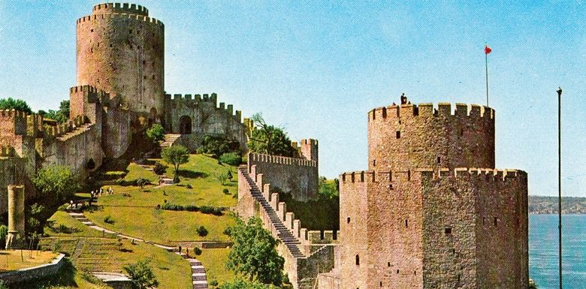

14

SULTANAHMED MOSQUE
This 17th century mosque, near Haghia Sophia, is famous for the beautiful blue tile work ornamenting its walls. Its surrounding six slim minarets distinguish it from other mosques which normally have two or four minarets. It was built by architect Mehmet Aga by the order of Sultan Ahmed I as a complex in seven years and became the most important mosque of the city, right in Sultanahmet square.

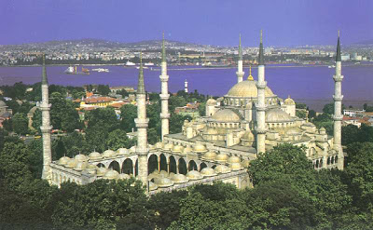

15

You must absolutely eat
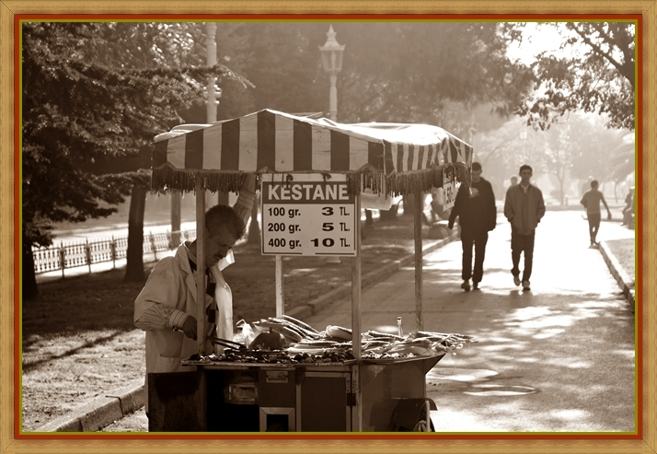

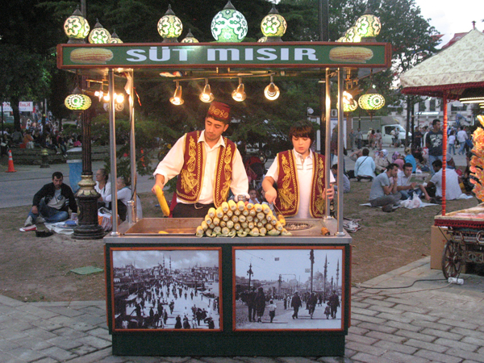
16

GÜLHANE PARK
Gülhane Park was once the outer garden of Topkapı Palace, accessible only to the royal court. These days crowds of locals come here to picnic under the many trees, promenade past the formally planted flowerbeds, and enjoy wonderful views of the Bosphorus, Sea of Marmara and Princes' Islands from the Set Üstü Çay Bahçesi on the park's northeastern edge. The park is especially lovely during the İstanbul Tulip Festival, when tulips are arranged to resemble nazar boncuk 'evil eye' charms.
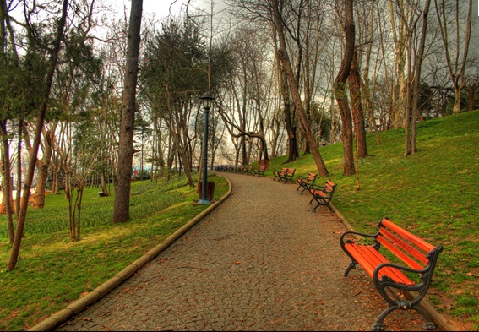

17

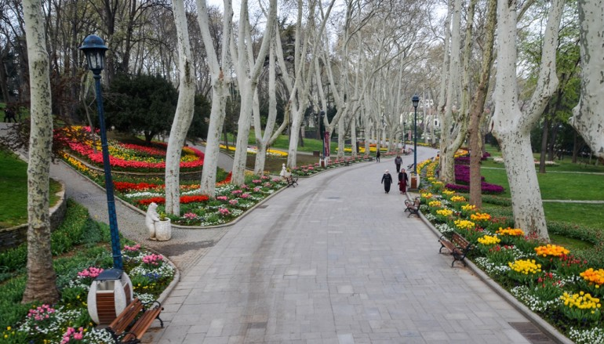
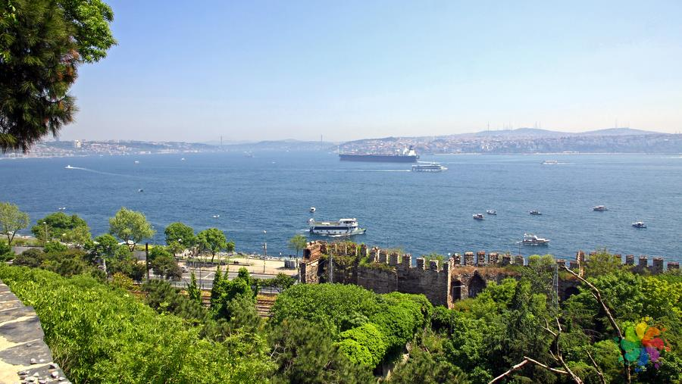
18

You must absolutely eat
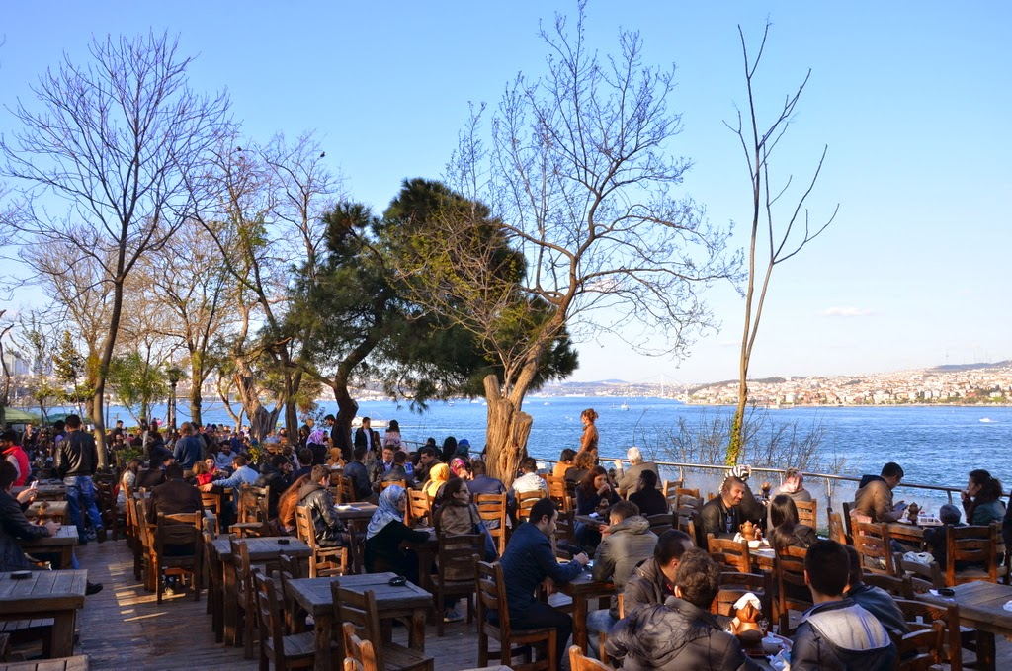
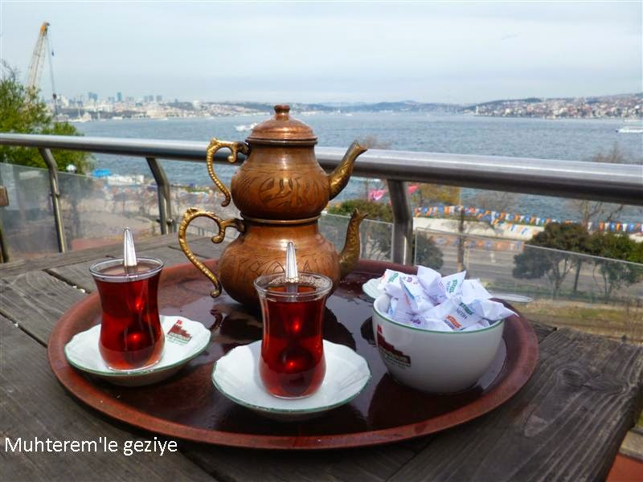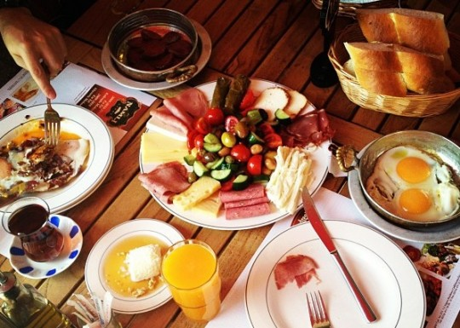
19

Ingredients

3 ==) ISTANBUL PROMOTION

4 ==) ISTANBUL PROMOTION

5 ==) THE TAKSIM SQUARE
6 ==) THE FATİH SULTAN MEHMET BRIDGE

7 ==) THE SÜLEYMANIYE MOSQUE

8 ==) THE LEANDROS TOWER
9 ==) THE GALATA TOWER

10 ==) THE GALATA TOWER

11 ==) THE DOLMABAHÇE PALACE MUSEUM

12 ==) THE DOLMABAHÇE PALACE MUSEUM
13 ==) THE FORTRESS

14 ==) THE FORTRESS
15 ==) SULTANAHMED MOSQUE

16 ==) SULTANAHMED MOSQUE
17 ==) GÜLHANE PARK

18 ==) GÜLHANE PARK

19 ==) GÜLHANE PARK

