Students’report Póvoa de Lanhoso, Portugal

In an Erasmus+ program called ’Acting for a better Europe’, 4 of our students (Vörös Lili, Török Léna, Szabó Réka, Sáfrány Anna) and 2 teachers (Leirerné Katona Ágnes, Pataki Mónika) had the chance to travel to Portugal from 29th May to 4th June.

The journey started on Sunday when we travelled from Csongrád to Budapest to take the plane and fly to Barcelona. We headed to Porto, Portugal from Barcelona. Then, we took a taxi to Póvoa de Lanhoso. After our arrival, we all spent the rest of the day with our hosting families.

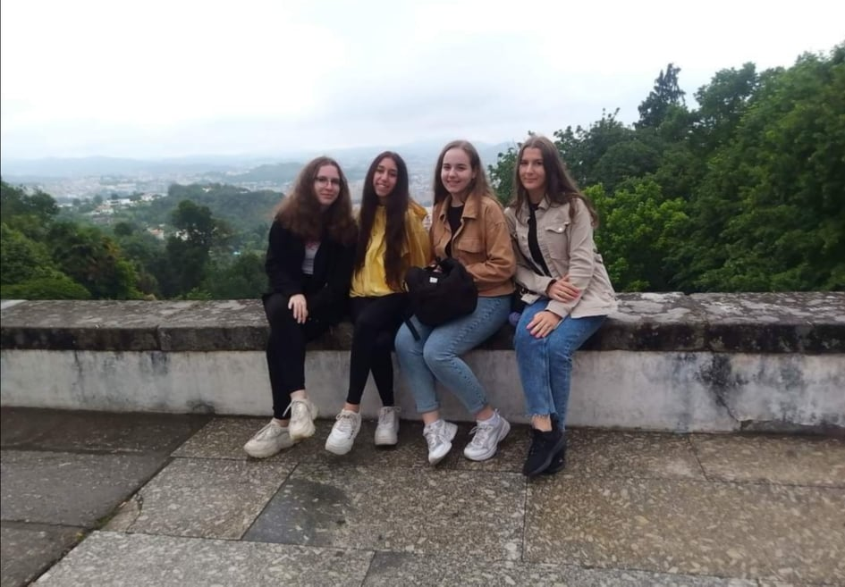

On Monday morning, the students showed us their amazing school, then we had to do groupworks to get to know each other better. We had lunch at the school, then walked to the town hall where the mayor greeted all the foreign students warmly. After the cordial welcome, we learned a little about the town, visited the local castle and a place called ’Bom Jesus’. After sunset, all of the students played football at the nearby park and went to a restaurant together after the game.

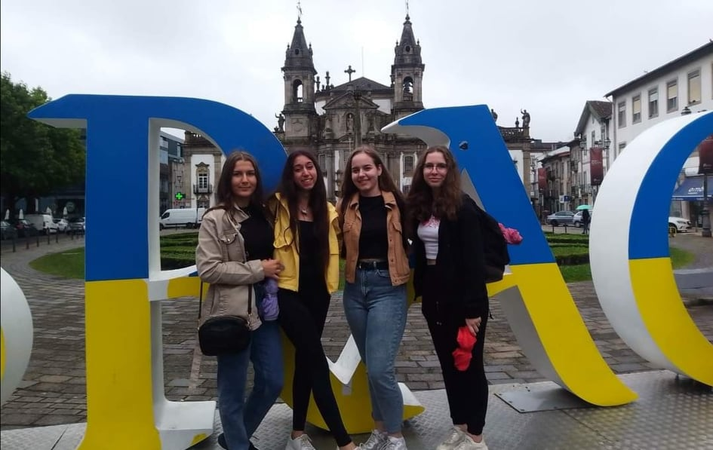

On Tuesday, we took a full-day trip to Braga and visited the most beautiful theater we have ever seen. We also walked on the shore of the Atlantic Ocean. We went to a picnic place after the sightseeing and ate a lot of tasty foods.

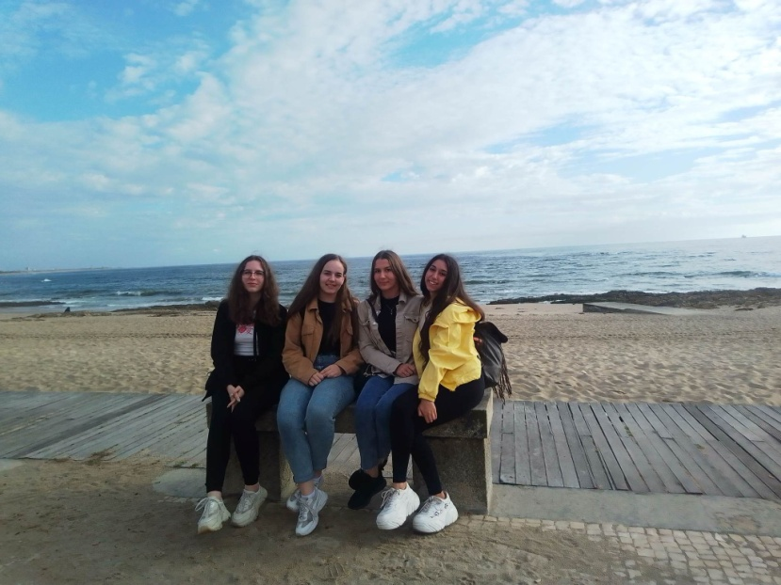

Wednesday was the teamwork’s day. The students divided into 5 groups of different topics and we worked on a project we could show on the last day. We had lunch at school and took the bus to Geres, where we got to know the attractions of the town and the nature given treasures. After we had dinner with our host families, we were able to attend the performance of the school orchestra and choir.

On Thursday, a trip took place again. We travelled to Guimaraes and visited the castle where we scattered into two groups. The first group participated in a renaissance dance activity, while the other group was shown around the castle by a tour guide. In the afternoon, we took part in an event called ’Eco Peddy Paper’. In the evening, we mostly spent time with our hosts.

On Friday, we finished our group projects and presented them to all of the participants of this Erasmus program. After, we took our last walk together in the town. We had a farewell dinner at the school and ate delicious foods that were mostly made by the students’ parents. Some countries’ students’ tavelled home at night so we said goodbye to them. 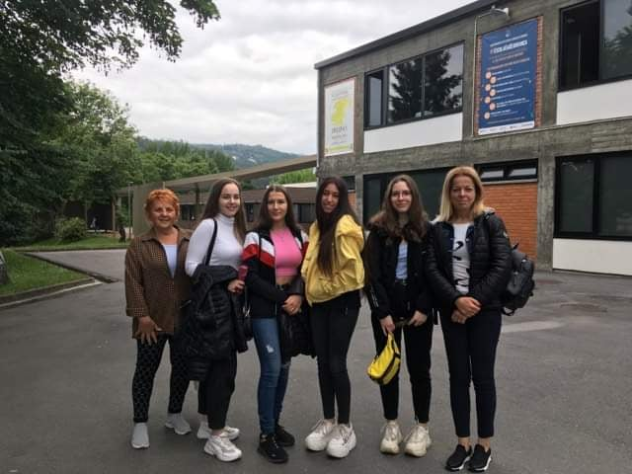

Saturday was the day of the not-so-happy farewell. We still had some time to spend with the hosting families and we had lunch together. In the early afternoon, we went to the school and said goodbye once again to the portugese students and teachers. Then, we took the taxi to Porto and flew straight home.

Overall, everyone had a great time in Portugal because of the kind people we met, the trips we took and the friends we made.