Leaflets and Brochures

Leaflets and Brochures are printed documents, usually illustrated and distributed free. Their functions can include commercial advertising, persuasion and information.
A good leaflet is one that makes people want to pick it up and read it.

Useful tips when writing a leaflet/brochure.

- Give your leaflet an eye- catching title and break the text into short sections with appropriate headings.
- Avoid heavy and complex sentences.
- Address the reader personally e.g. You’ll be able to visit…
- Use imperatives e.g.
Discover the real meaning of ancient times
Don’t miss the opportunity
Step back in time
Enjoy a long walk
Fancy a great experience visiting..
Are you interested in modern Art?
- Ask rhetorical questions e.g. Have you ever wanted to get away from your daily routine and discover….
- Use exaggeration adjectives e.g. superb/magnificent/exciting/the best /fabulous/fascinating/the greatest…

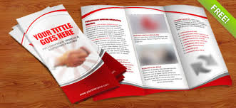
E.A.

